INTRODUCTION TO NEW U.ACHIEVE SELF-SERVICE for Staff

The purpose of this document is to show current UNM advisors and staff how to run a LoboTrax Audit in UNM Loboweb.
In fall 2015 we will be upgrading our degree audit client from DARwin to the U.Achieve client. This upgrade will change the way UNM staff and students access the LoboTrax audit.
LOGGING IN:
- Go to MYUNM: https://my.unm.edu/cp/home/displaylogin
- Log in with your current UNM net ID and password.
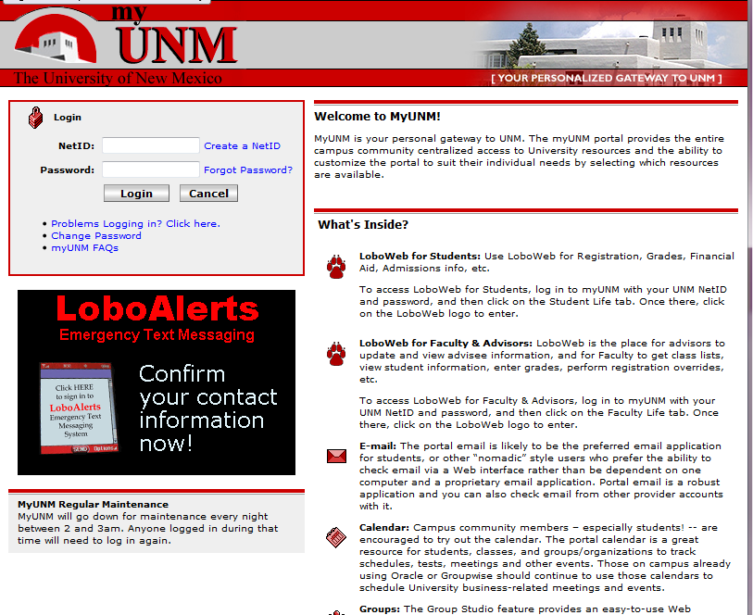
EMPLOYEE LIFE TAB:
- Click on the EMPLOYEE life tab.
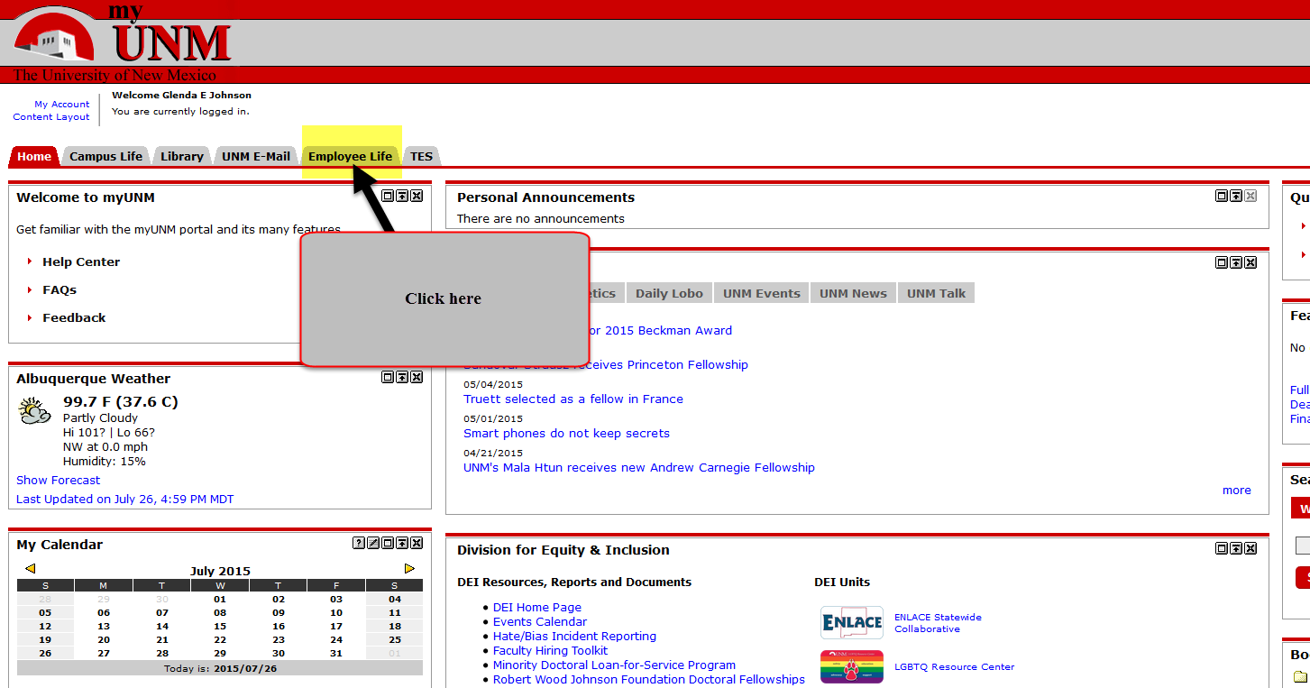
- Click on the LOBOWEB link.
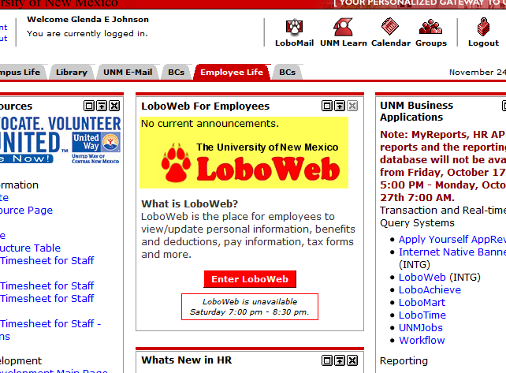
- Then click on the “Faculty & Advisors” tab.
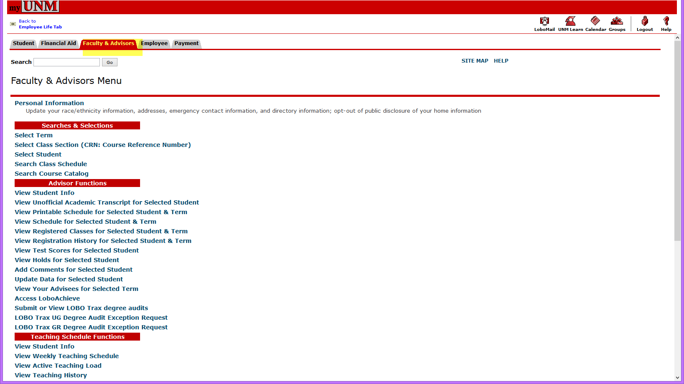
- Scroll down to “Submit or view LOBO Trax degree audits” link and click on it.
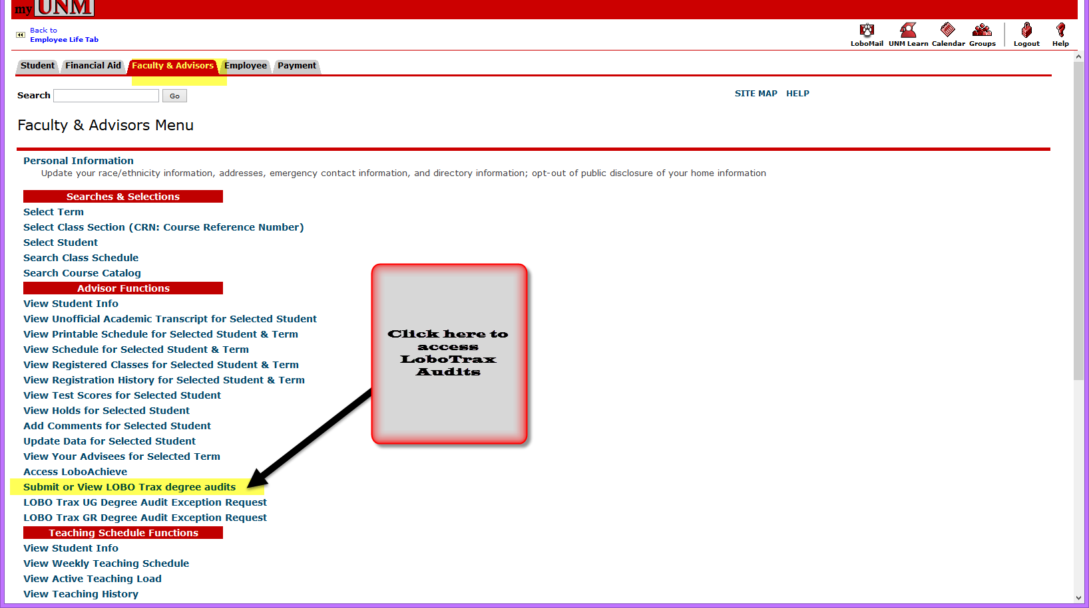
- Click on the “Submit an Audit” link.
- You will need to sign in a second time so reenter your UNM Net ID and Password.
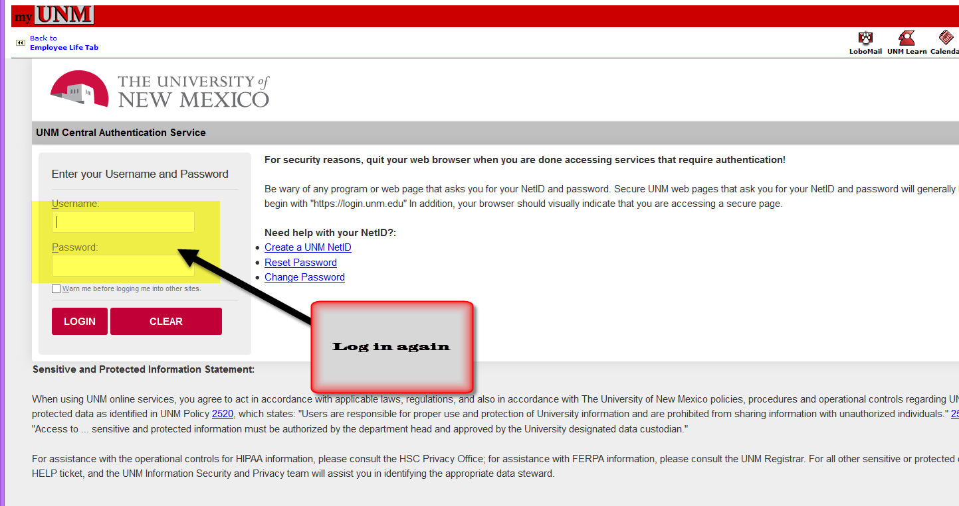
- Now you are in the new U.Achieve “LoboWeb” dashboard, see below:
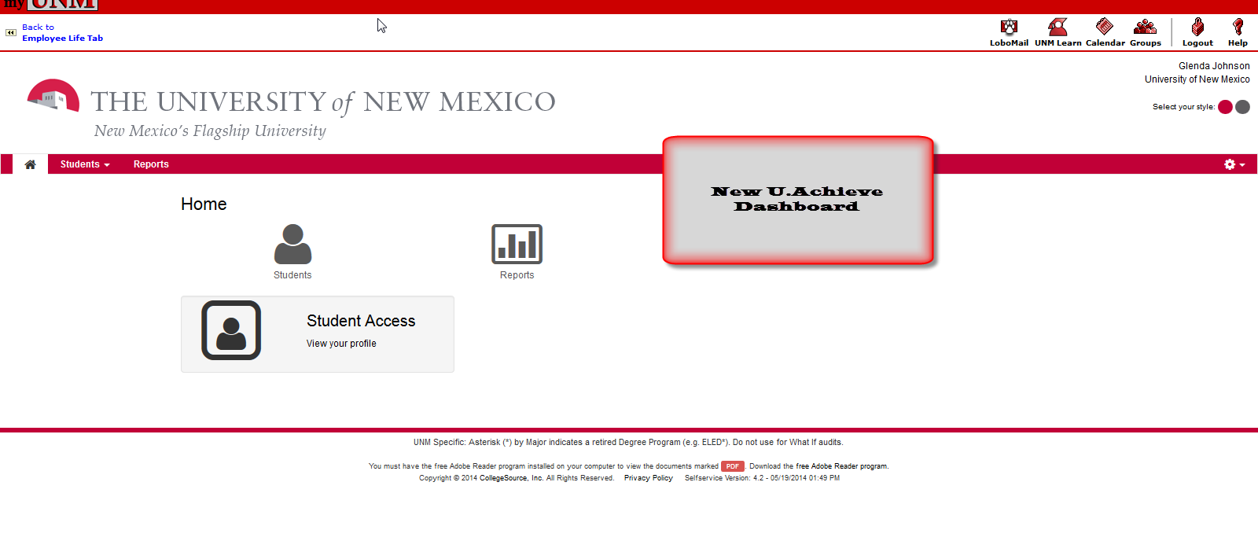
- To run a LoboTrax audit, click on the “STUDENTS” icon.
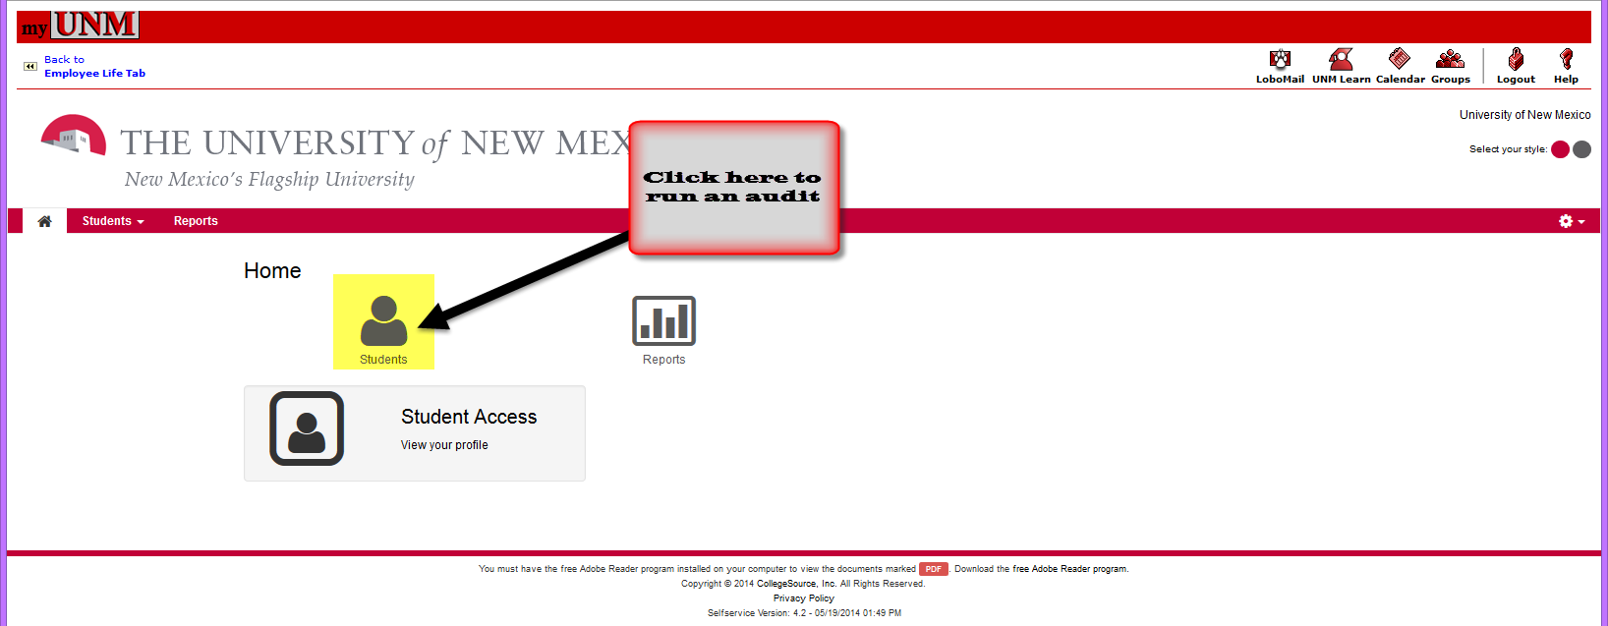
- Enter the student’s Lobo (Banner) ID and click on “SUBMIT.” If you don’t know the student ID number you can also search by name now. See below:
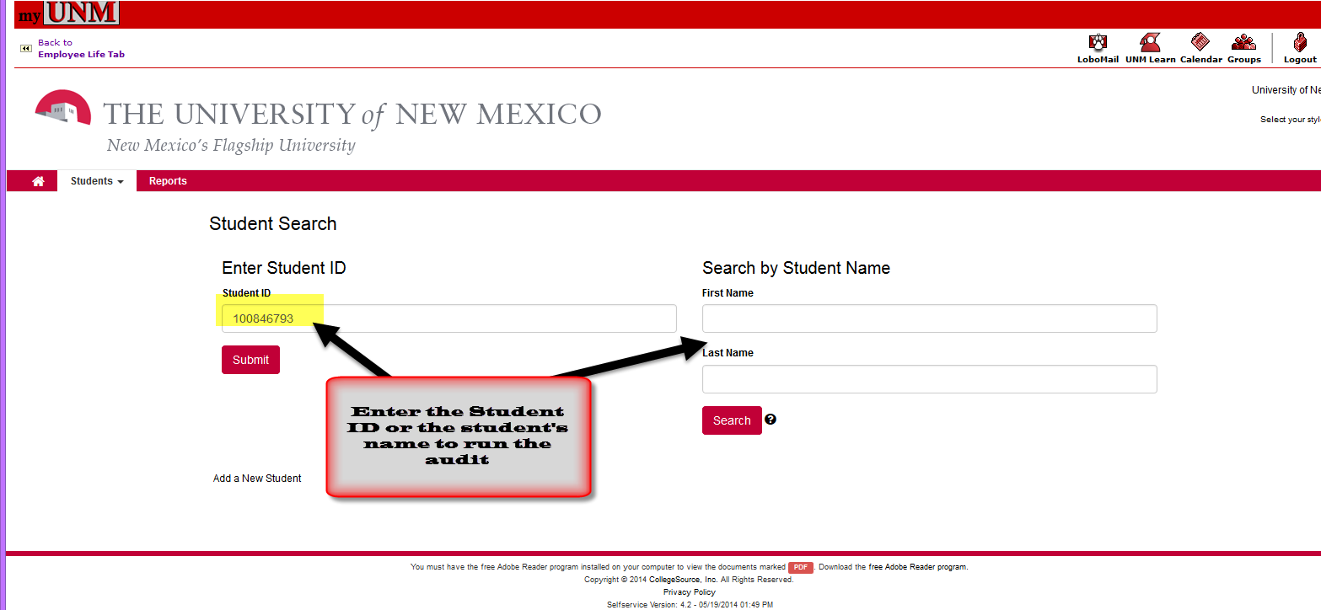
- Now you have the choice of running an audit for the student’s current program or running a “What If” audit.
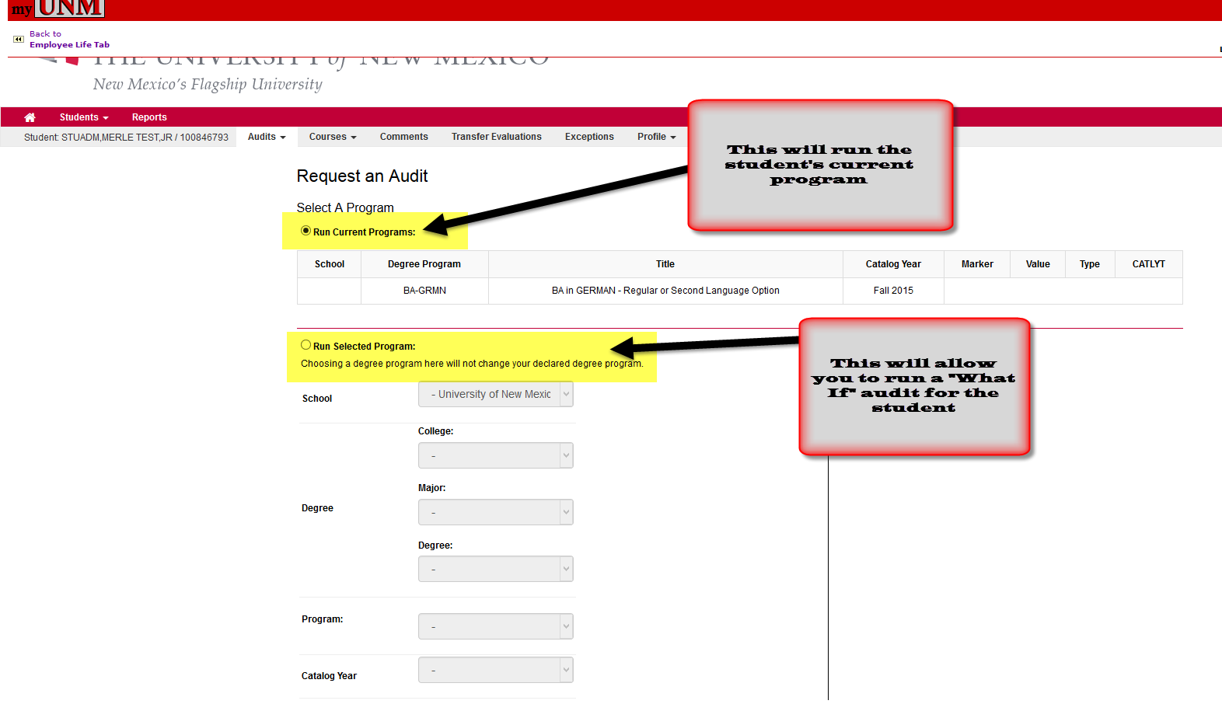
- To run the student’s current degree program leave the “Run Current Program” radio button selected, scroll to the bottom and select the “Run Audit” button. See below:
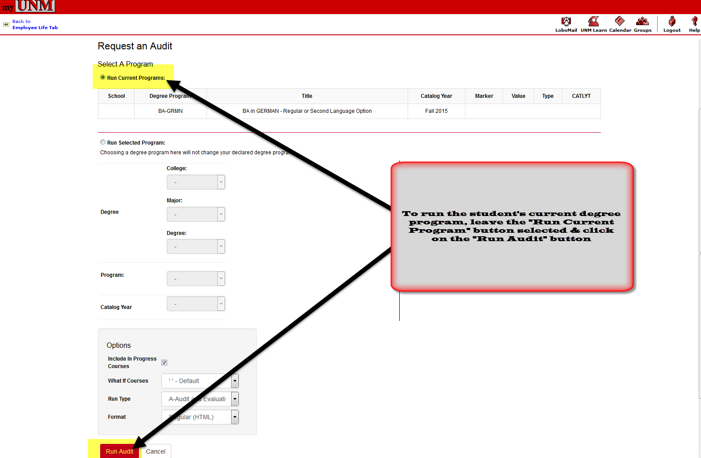
- If you want to run a “What If” audit then you will need to select the “Run Selected Program” button and fill in the necessary program information. Click on the “Run Audit” button to run the audit.
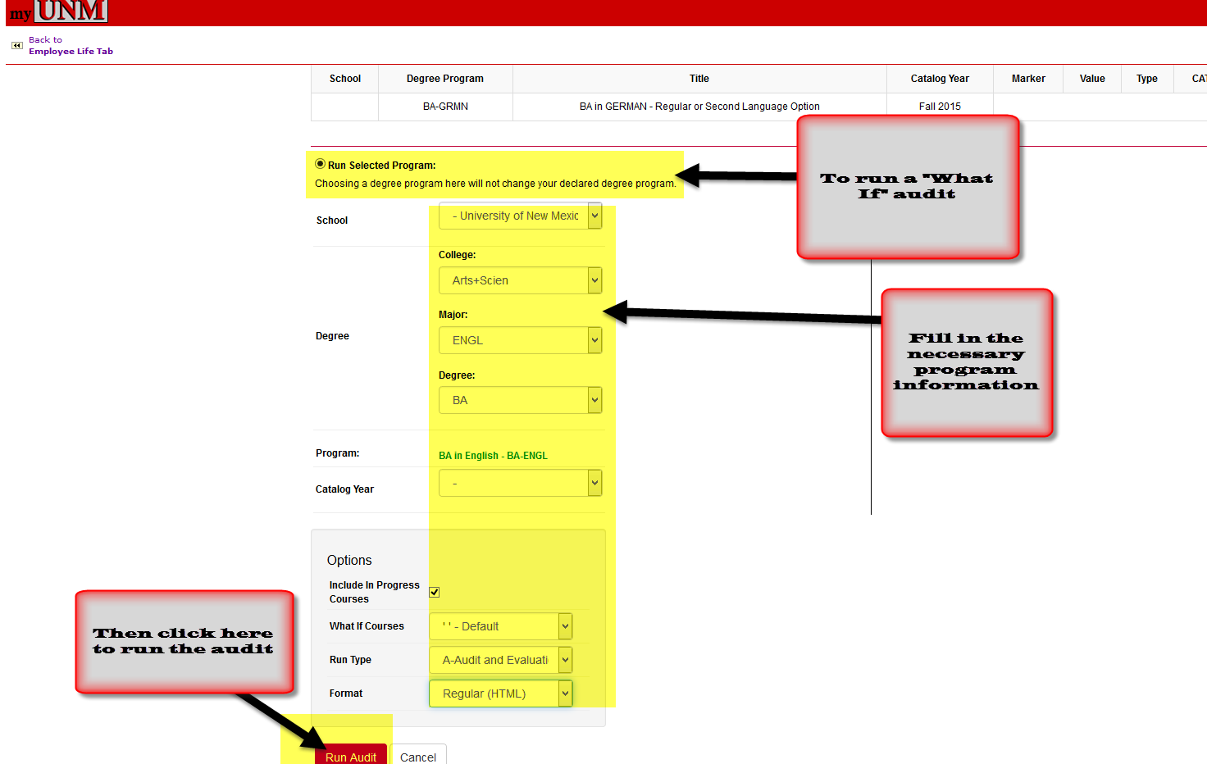
- As your audit is processing you will see this screen:
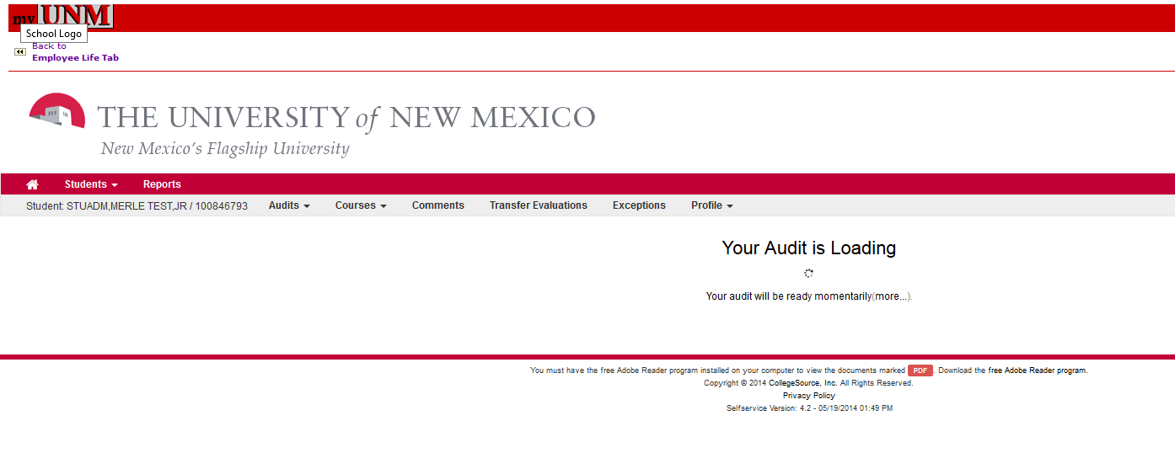
- When the audit is done running you will see a list of audits run within the last day or so. To open the audit you just ran, find it in the list and then click on the “View Audit” link to open it.
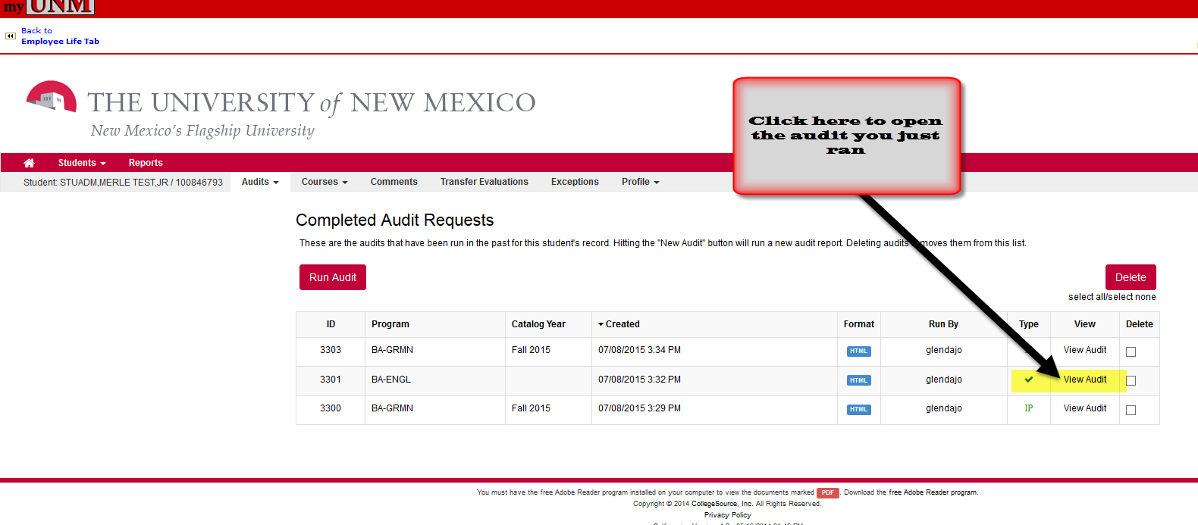
- The “What If” audit opens and looks much like the old LoboTrax Audits did as you will see in the example below:
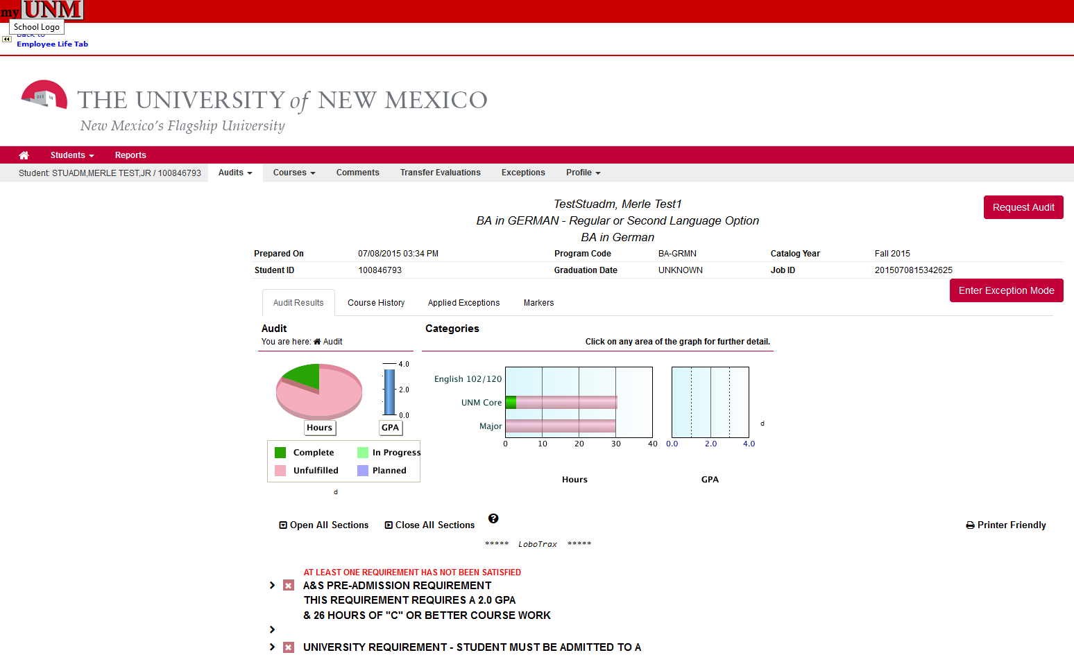
- There are some new features in the U.Achieve LoboTrax Audit found in the tabs to the right of the student’s name, see below:
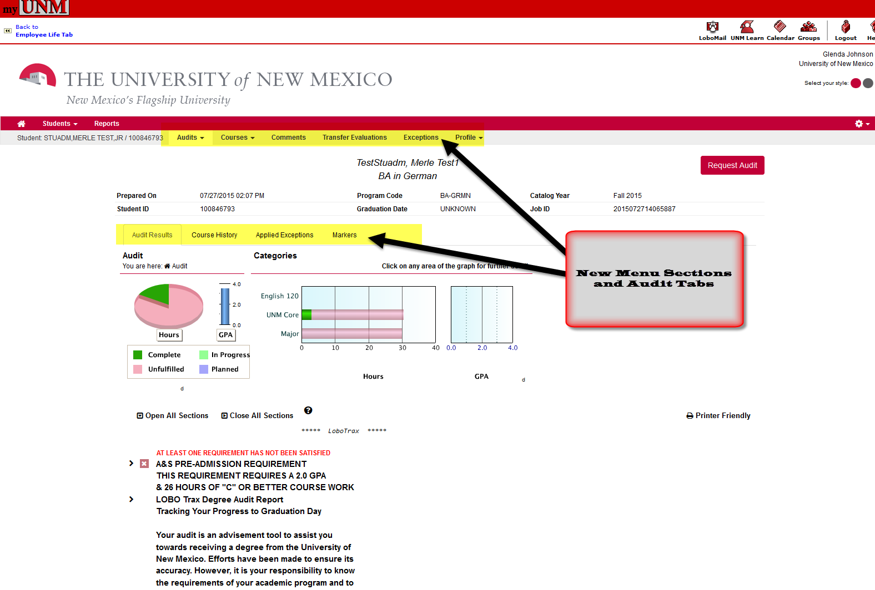
- MENU FEATURES:
  - First Menu Section-AUDIT: Shows you the audit you just ran for the student, see below:
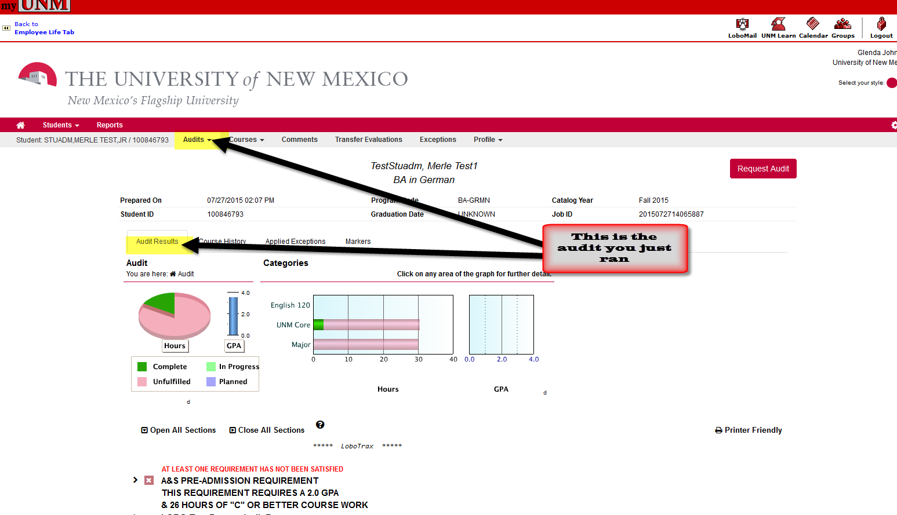
    - Under the “AUDITS” area right above the graphs and charts you can see four different tabs within the student’s LoboTrax Audit:
      - AUDIT RESULTS TAB: click on this tab to see the audit you just ran.
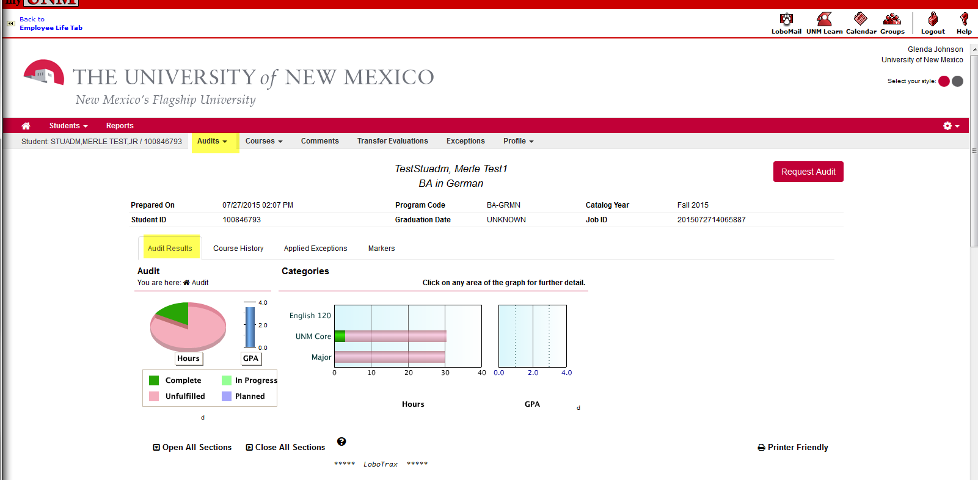
      - COURSE HISTORY TAB: You will see the student’s completed courses, both UNM and transfer courses.
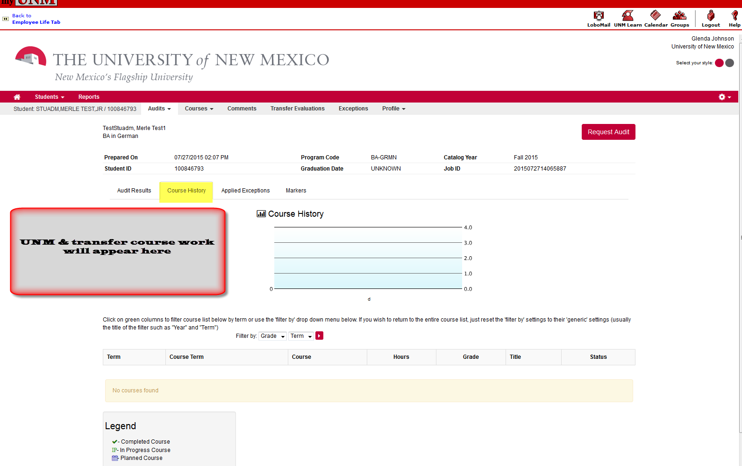
      - APPLIED EXCEPTIONS TAB: If the student has any exceptions applied to a degree program you will be able to see them under this tab.
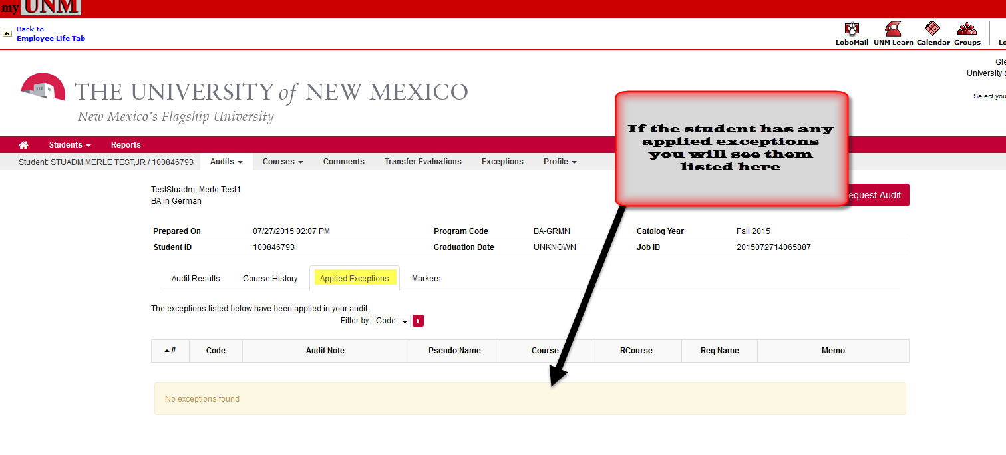
      - MARKERS TAB: If the student has any markers for his/her degree program you will see them under this tab.
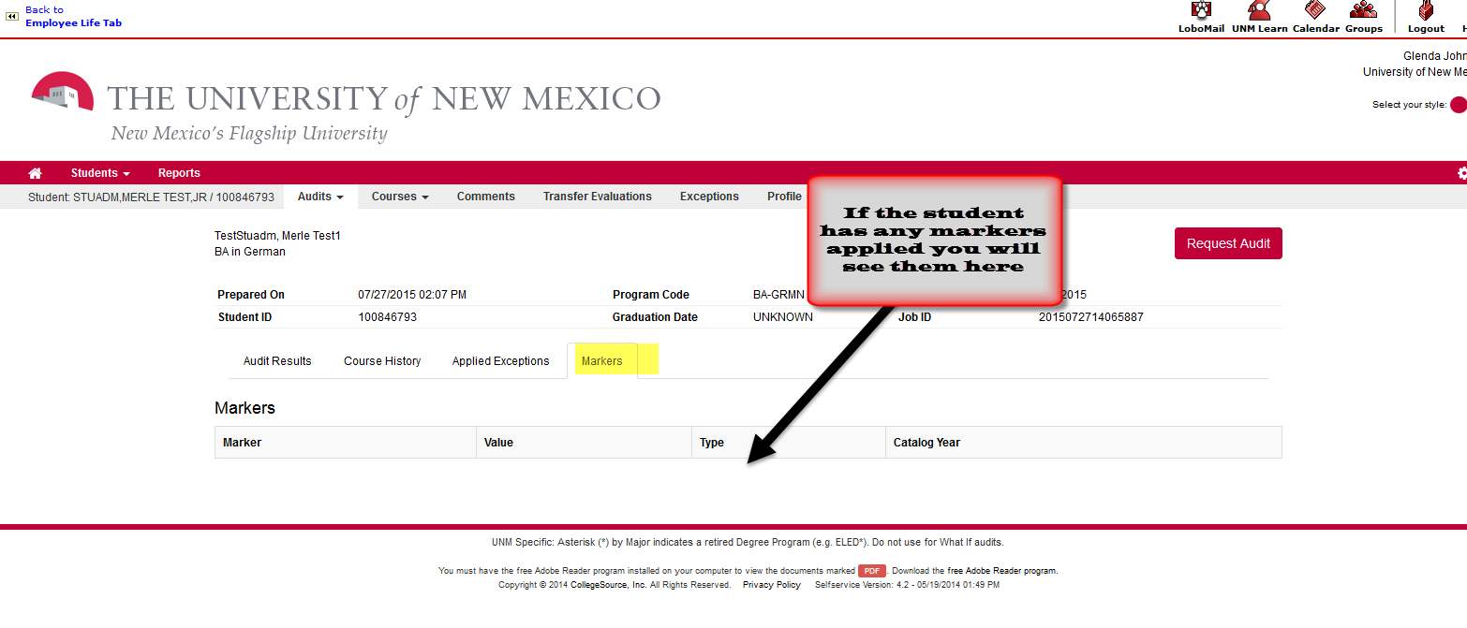
  - Second Menu Section-COURSES:
    - HOME: Displays all completed UNM and transfer courses. Questions regarding a student’s UNM record should be directed to the Registrar’s Office via email at: unmreg@unm.edu.
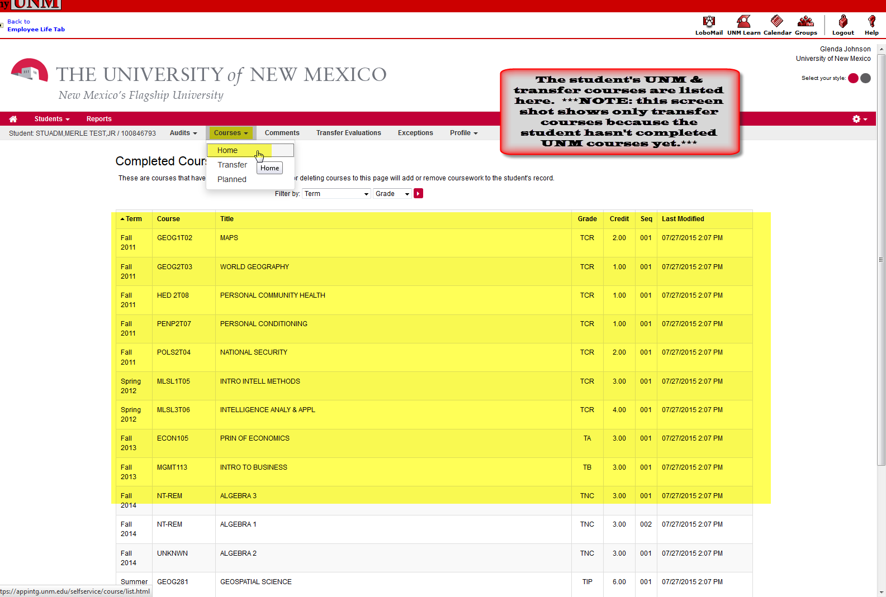
    - TRANSFER: Displays all completed transfer courses. For more information about running a Transfer Evaluation see Student Info answer #3228. Questions regarding transfer course work should be directed to the Admission Office via email: apply@unm.edu.
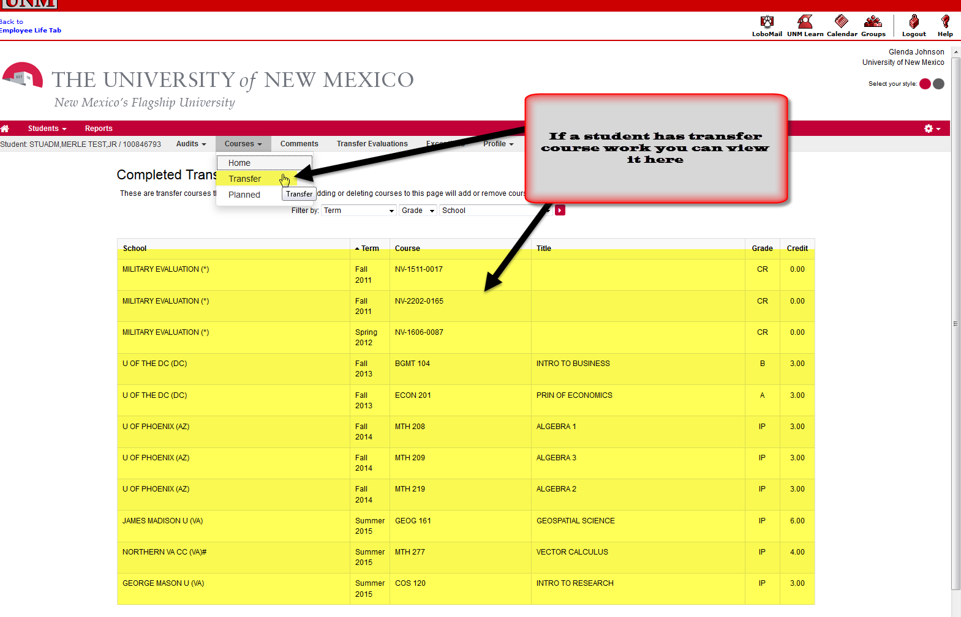
    - PLANNED: Displays any planned courses and allows user to add additional courses. *NOTE ABOUT PLANNED COURSES: Adding these courses to a student’s audit does NOT register him/her for the courses.*
      - More detail about Planned Courses below:
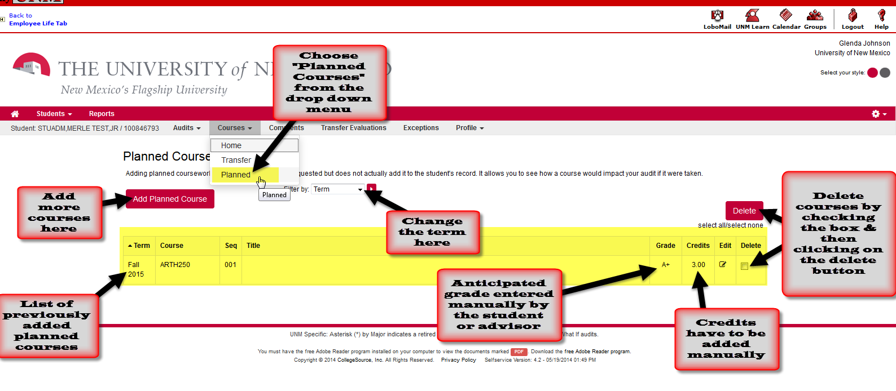
  - Third Menu Section-COMMENTS: Displays any comments from advisors.
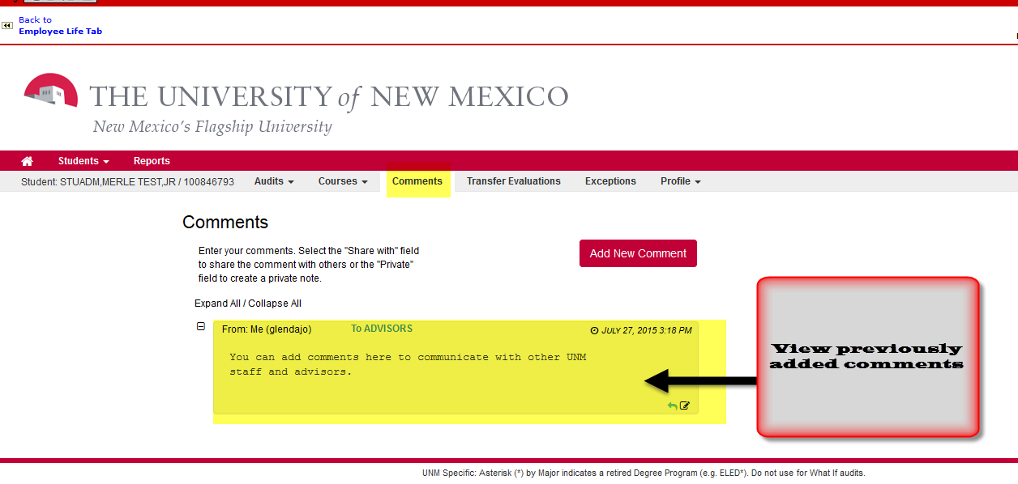
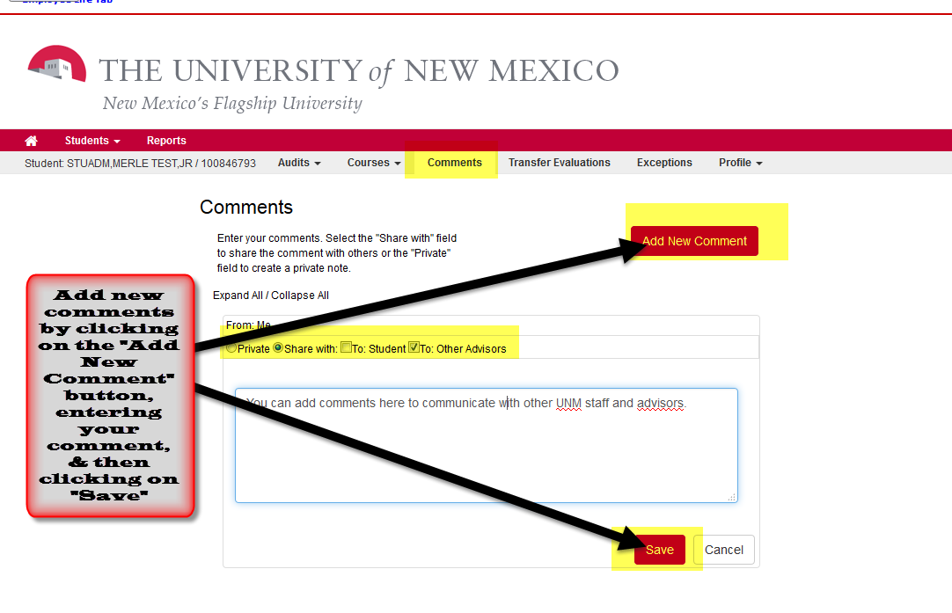
  - Fourth Menu Section-TRANSFER EVALUATIONS: This is where you can view a Transfer Credit Evaluation (TCE) for a student.
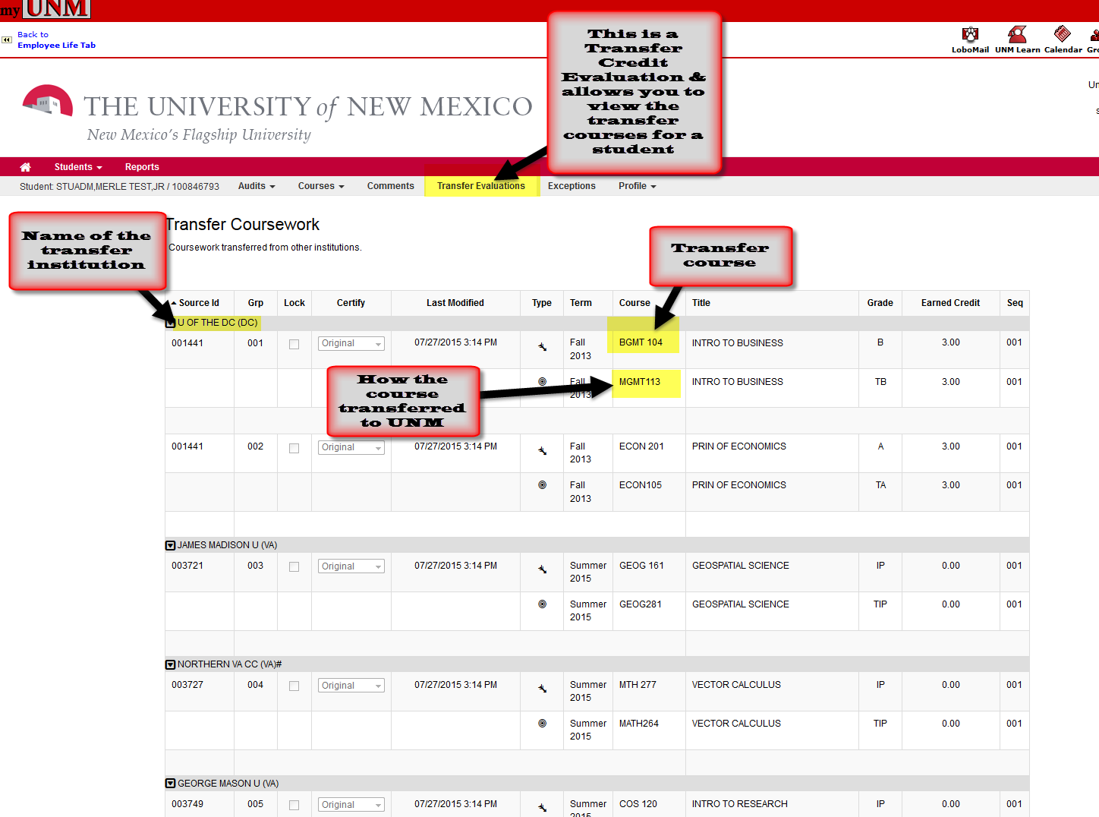
  - Fifth Menu Section-EXCEPTIONS: Displays any applied exceptions for the student.
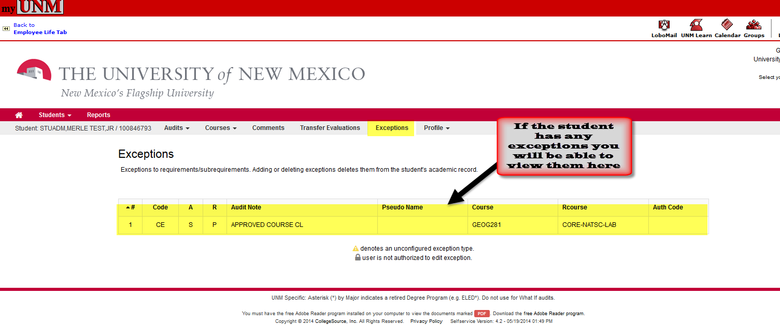
  - Sixth Menu Section-PROFILE: Displays the student’s current degree program and the demographic information.
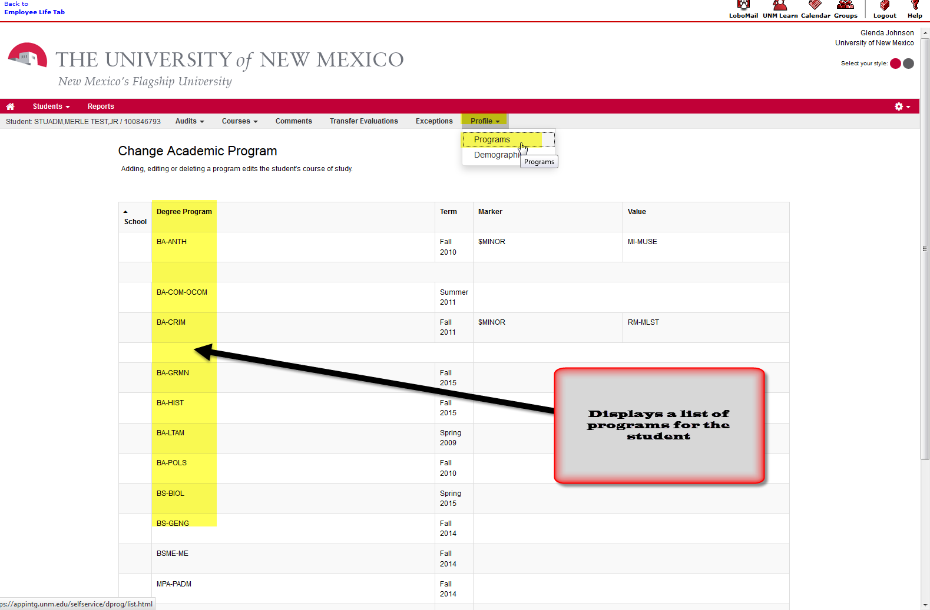
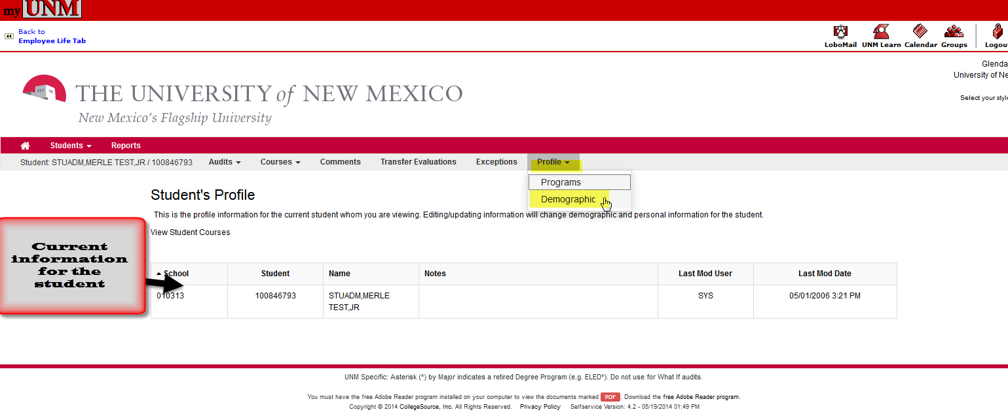
- Important information regarding audits:
  - Audits are only retained for a couple of days.
  - It is best to run a new audit each time to be sure you are viewing current data.
  - Questions regarding degree audit should be sent to the LoboTrax Degree Audit Team via email to: lobotrax@unm.edu.
  - Questions regarding processing of transfer transcripts should be sent to the Admission Office via email to: apply@unm.edu.
  - Questions regarding transfer articulation should be sent to the LoboTrax Transfer Team via email to: tes1@unm.eduOther resources:
- Student Info Answers:
    - #5124: What is a LoboTrax report?
    - #3052: How do I view a LoboTrax report?
    - #4193: How do I read and understand my LoboTrax audit?
    - #3228: How can I view my Transfer Course Evaluation?
*END*

