RUNNING A TRANSFER CREDIT EVALUATION (T.C.E.) IN LOBOWEB
The purpose of this document is to show current UNM students with transfer courses how to run a Transfer Credit Evaluation (TCE) in Loboweb.

In fall 2015 we will be upgrading our degree audit client from DARwin to the U.Achieve client. This upgrade will change the way UNM staff and students access the LoboTrax audit.
LOGGING IN:
- Go to MYUNM: https://my.unm.edu/cp/home/displaylogin
- Log in with your current UNM net ID and password.
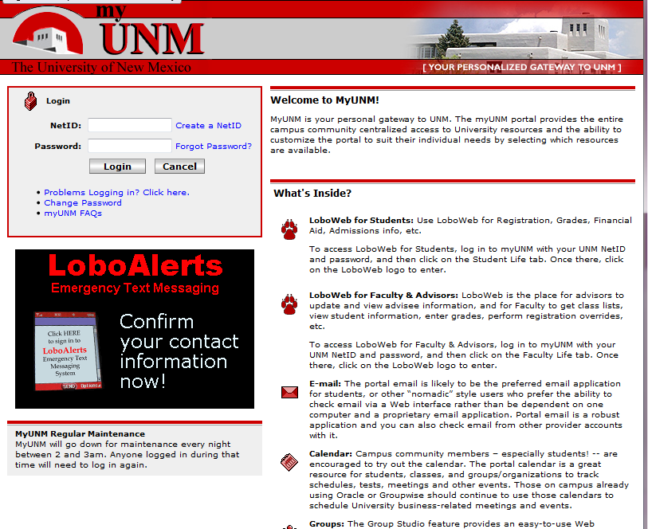
STUDENT LIFE TAB:
- Click on the STUDENT LIFE tab.
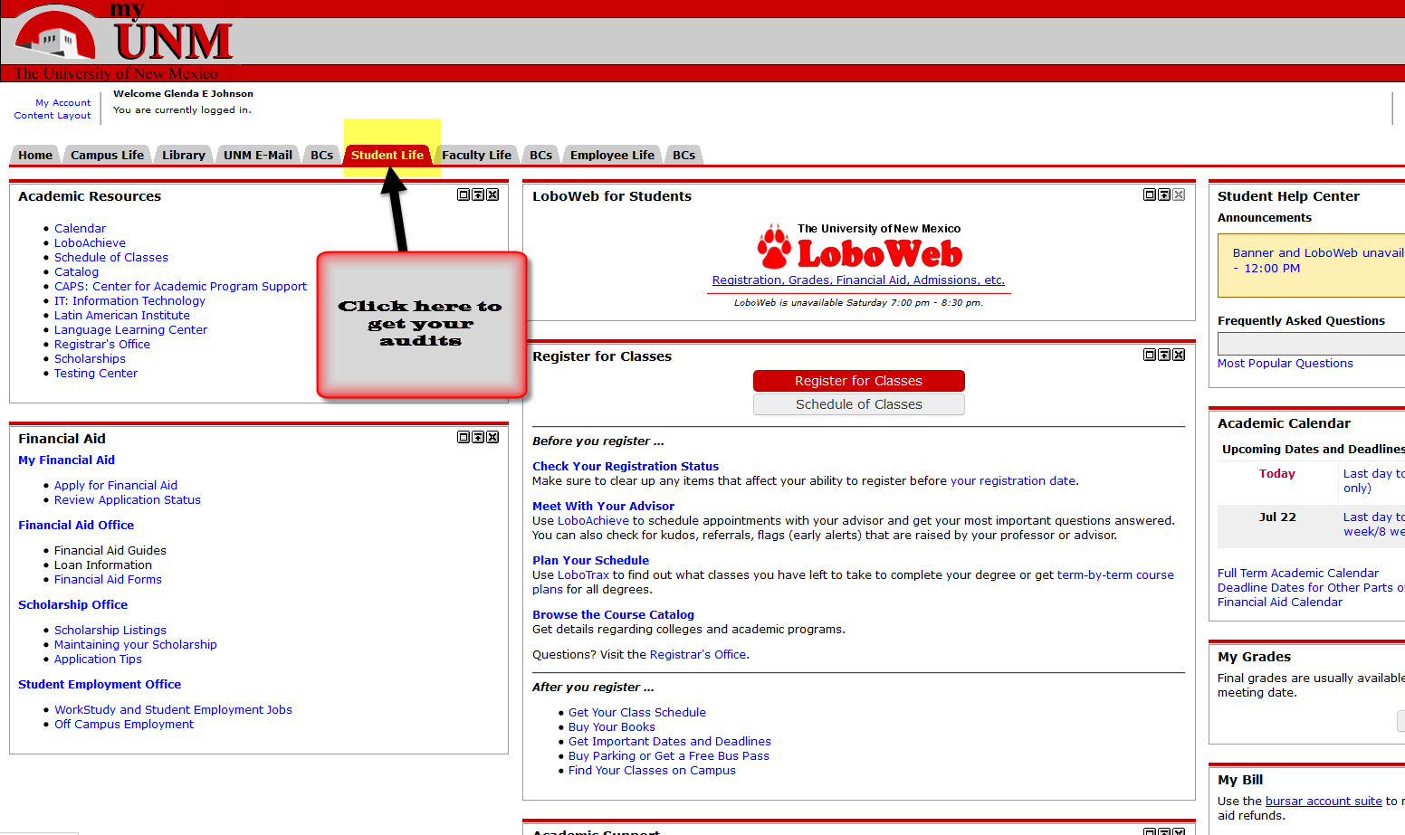
- Click on the LOBOWEB link.
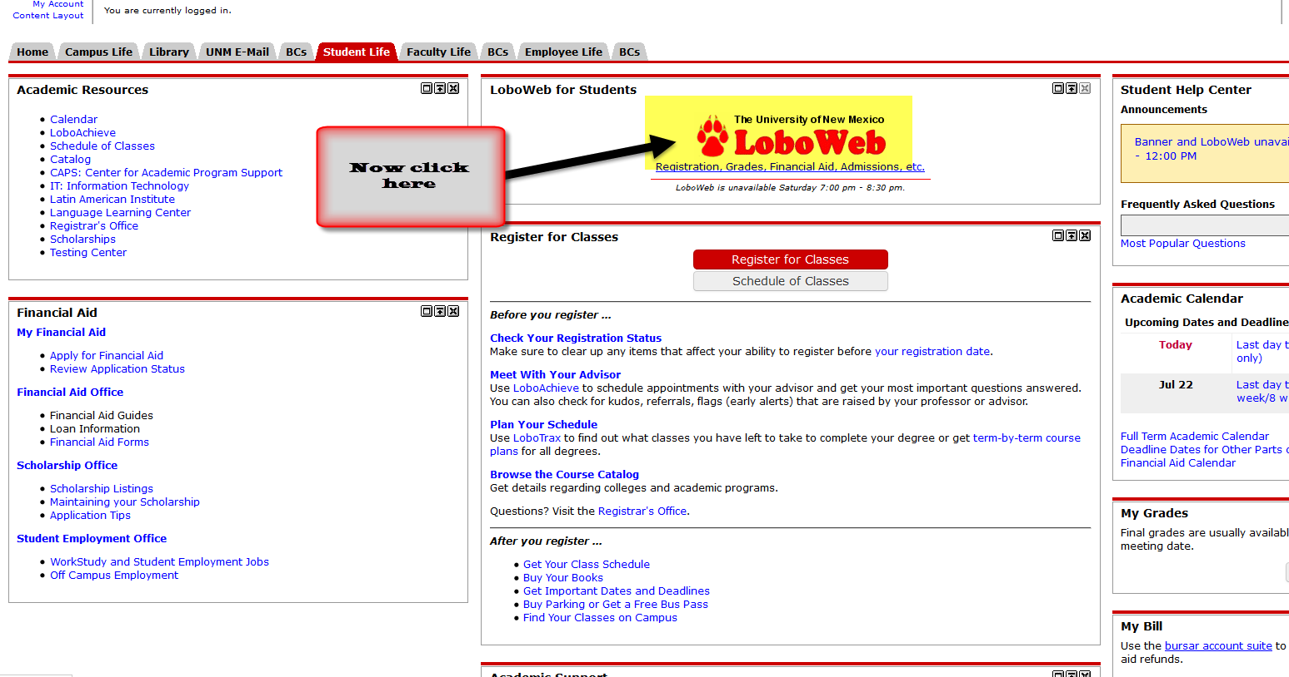
- Click on REGISTRATION & RECORDS link.
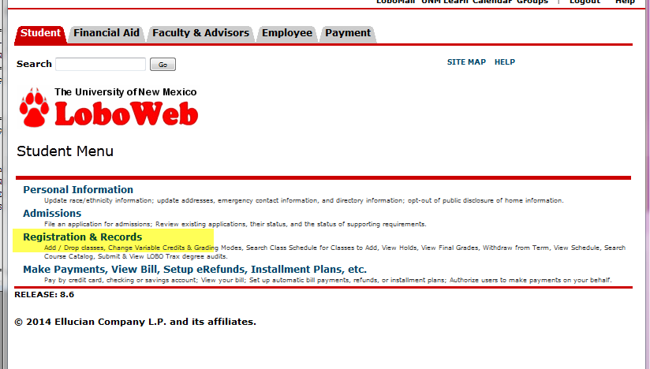
- Under the “RECORDS” section click on the “Submit or View LOBO Trax degree audits” link.
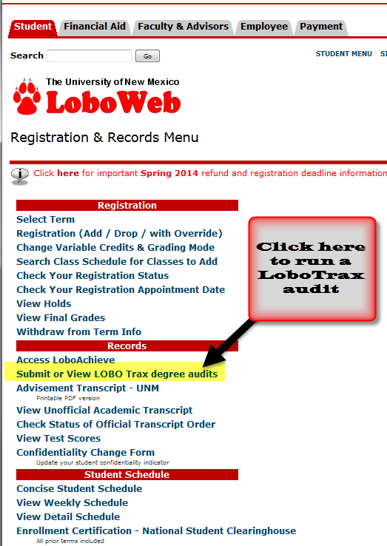
- Click on the “Submit an Audit” link to run your LoboTrax audit.
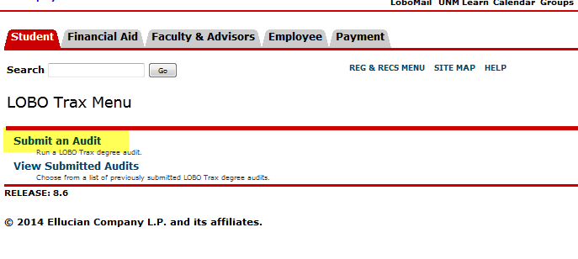
- You will need to sign in a second time so reenter your UNM Net ID and Password.
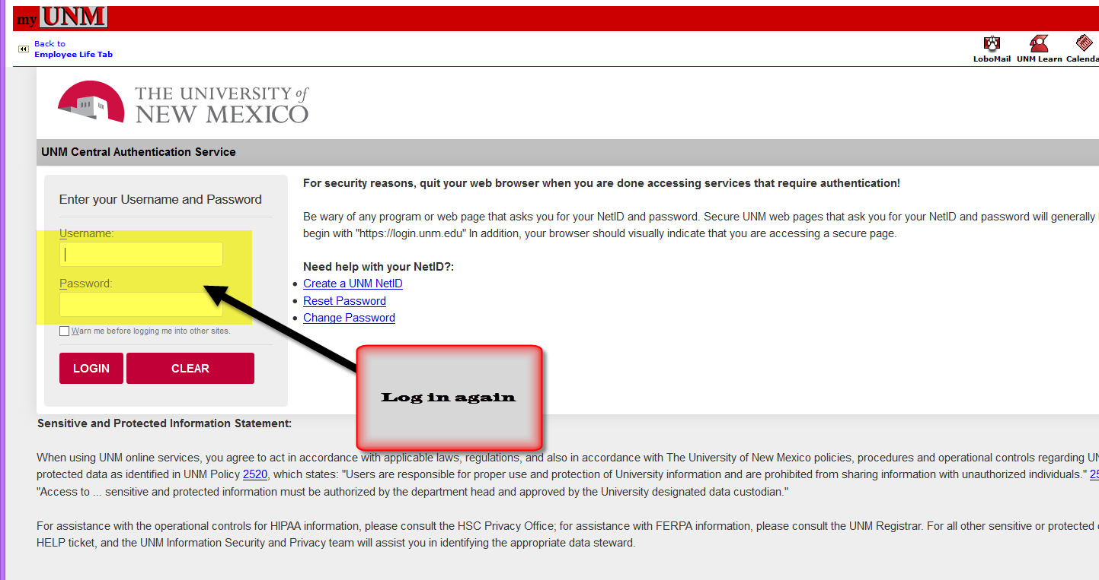
- Now you are in the new U.Achieve “LoboWeb” dashboard where you can run your audit, run a “What If” audit, view your courses, look at your exceptions, run a transfer evaluation, or look at your degree program profile.
- To view your TCE, you will first need to run a current audit so select the “Run Current Programs” radio button.
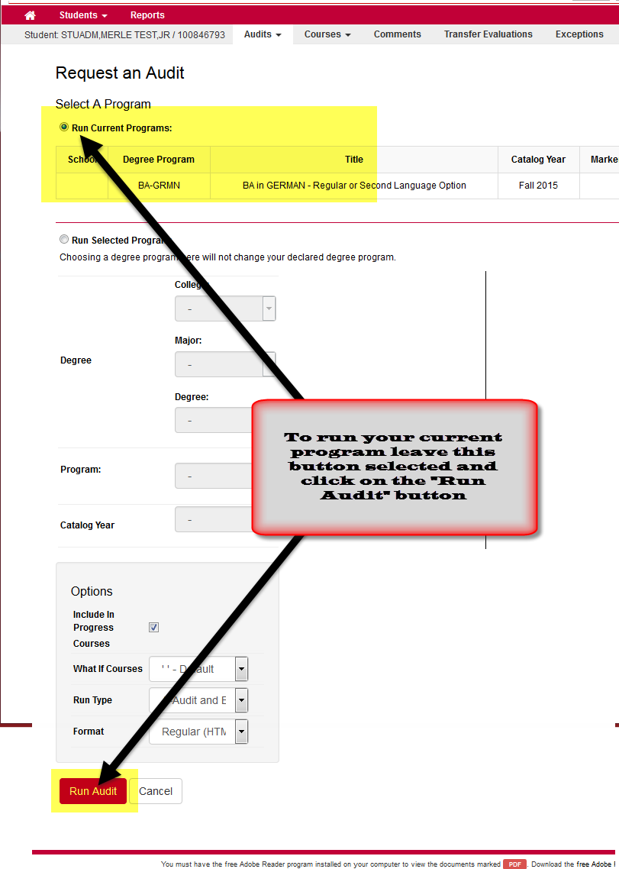
- Click on the “Run Audit” button to submit your request.
- As your audit is running you will see the following message:
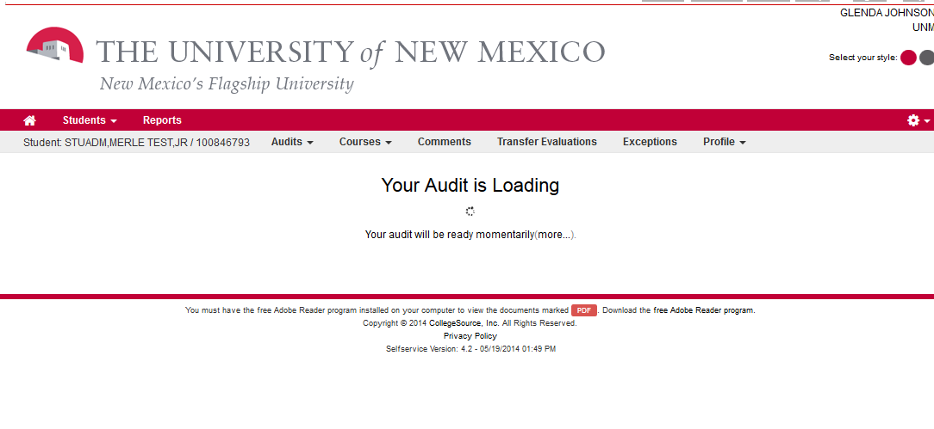
- When the audit is done you will see a list of audits run within the last day or so. To open the audit you just ran, find it in the list and then click on the “View Audit” link to open it.
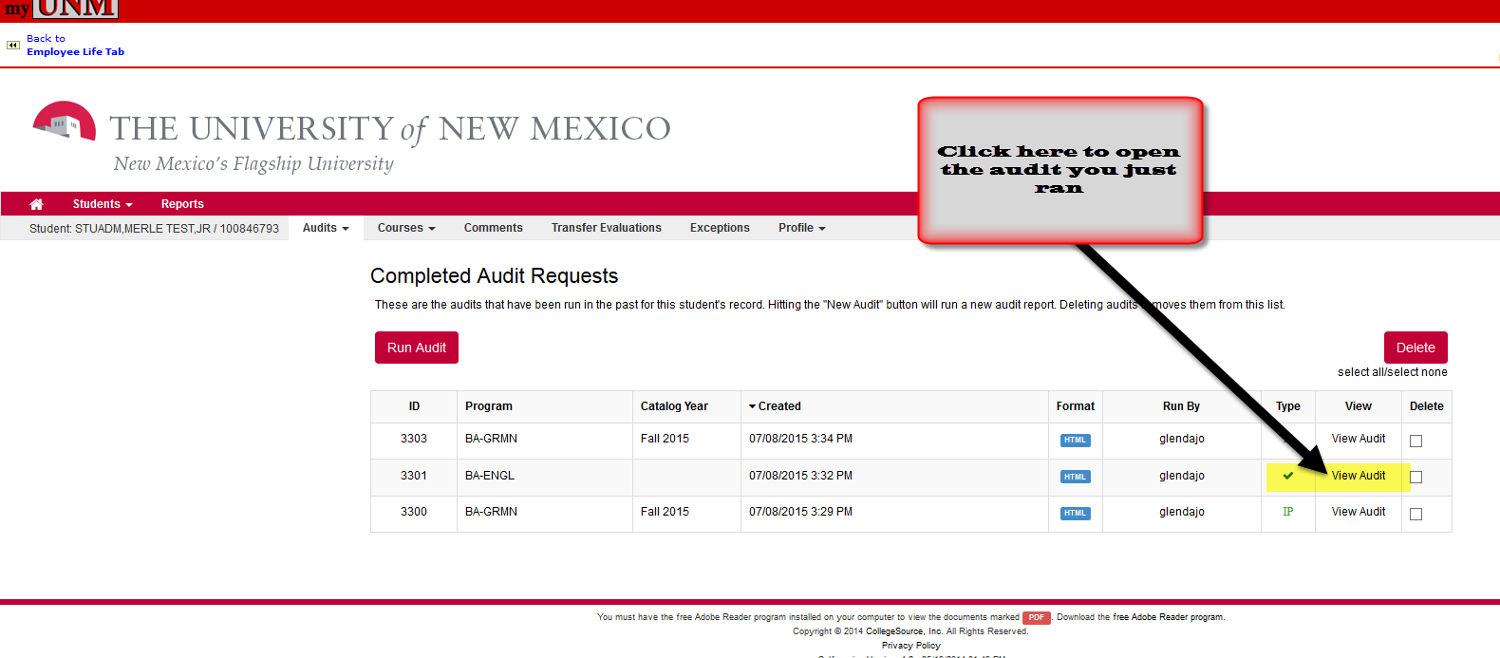
- Above your LoboTrax audit is a gray Menu Bar with several new functions including the “Transfer Evaluations” option.
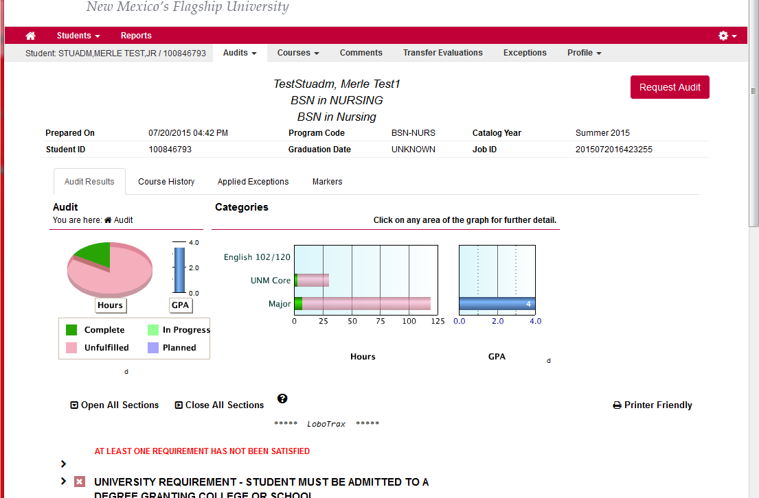
- To get to your TCE, click on the “Transfer Evaluation” link in the menu bar.
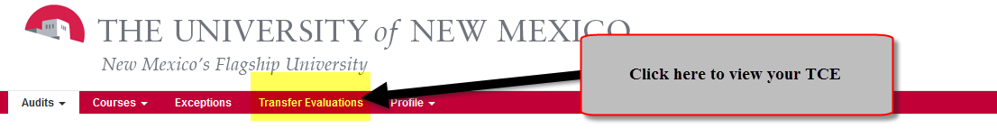
- Your TCE contains all completed transfer course work processed by the Admission Office and how they transferred to UNM.
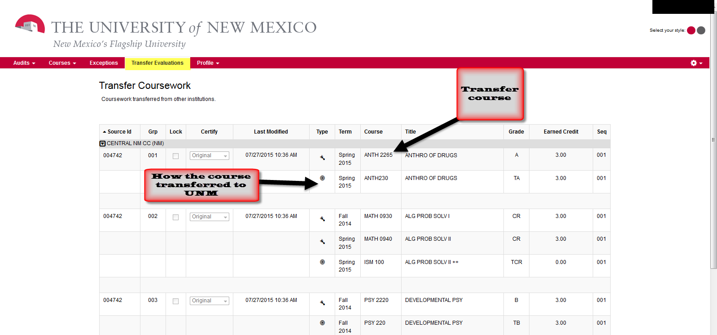
- Important information regarding audits:
  - Audits are only retained for a couple of days.
  - It is best to run a new audit each time to be sure you are viewing current data.
  - Questions regarding your degree should be directed to your academic advisor.
  - Questions regarding processing of transfer transcripts should be sent to the Admission Office via email to: apply@unm.edu.
  - Questions regarding degree audit should be sent via email to: lobotrax@unm.edu.
  - Questions regarding transfer articulation should be sent via email to: tes1@unm.edu.
- Other resources:
  - Student Info Answers:
    - #5124: What is a LoboTrax report?
    - #3052: How do I view a LoboTrax report?
    - #4193: How do I read and understand my LoboTrax audit?
*END*

