INTRODUCTION TO NEW U.ACHIEVE SELF-SERVICE for STUDENTS
The purpose of this document is to show current UNM students how to run a LoboTrax audit in UNM Loboweb.

In fall 2015 we will be upgrading our degree audit client from DARwin to the U.Achieve client. This upgrade will change the way UNM staff and students access the LoboTrax audit.
LOGGING IN:
- Go to MYUNM: https://my.unm.edu/cp/home/displaylogin
- Log in with your current UNM net ID and password.
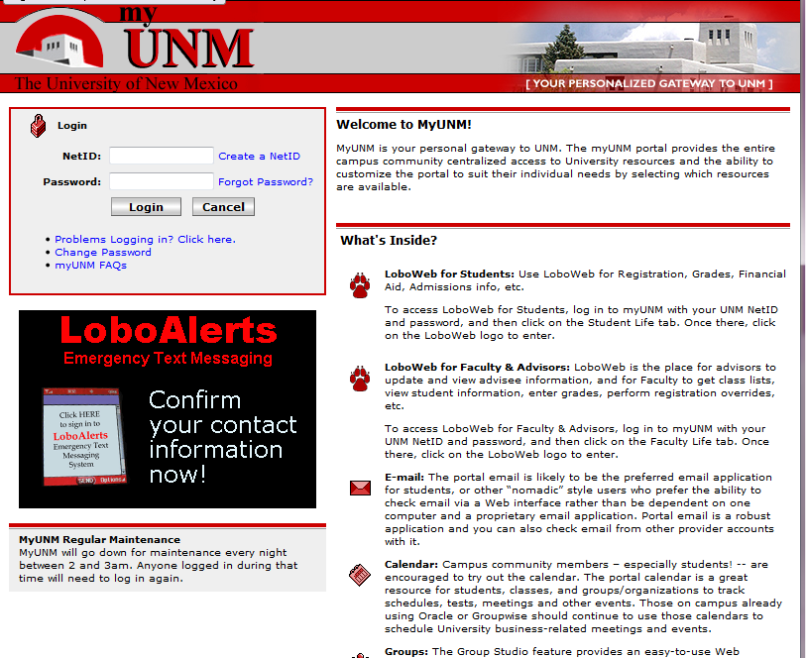
STUDENT LIFE TAB:
- Click on the STUDENT LIFE tab.
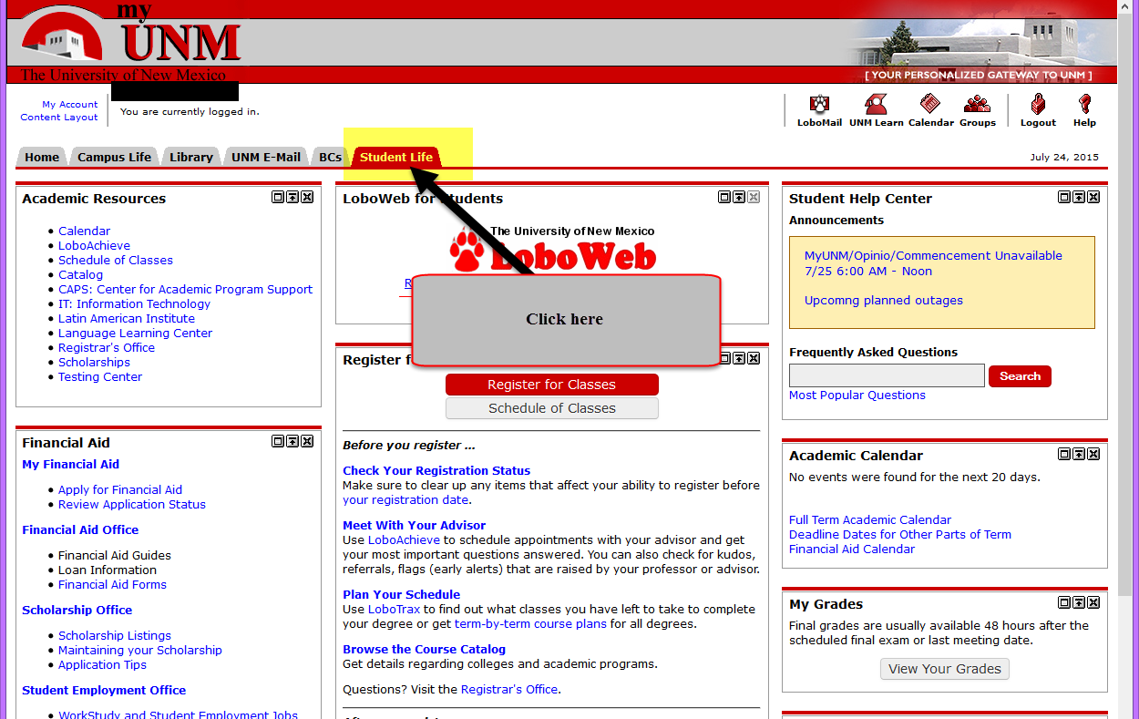
- Click on the LOBOWEB link.
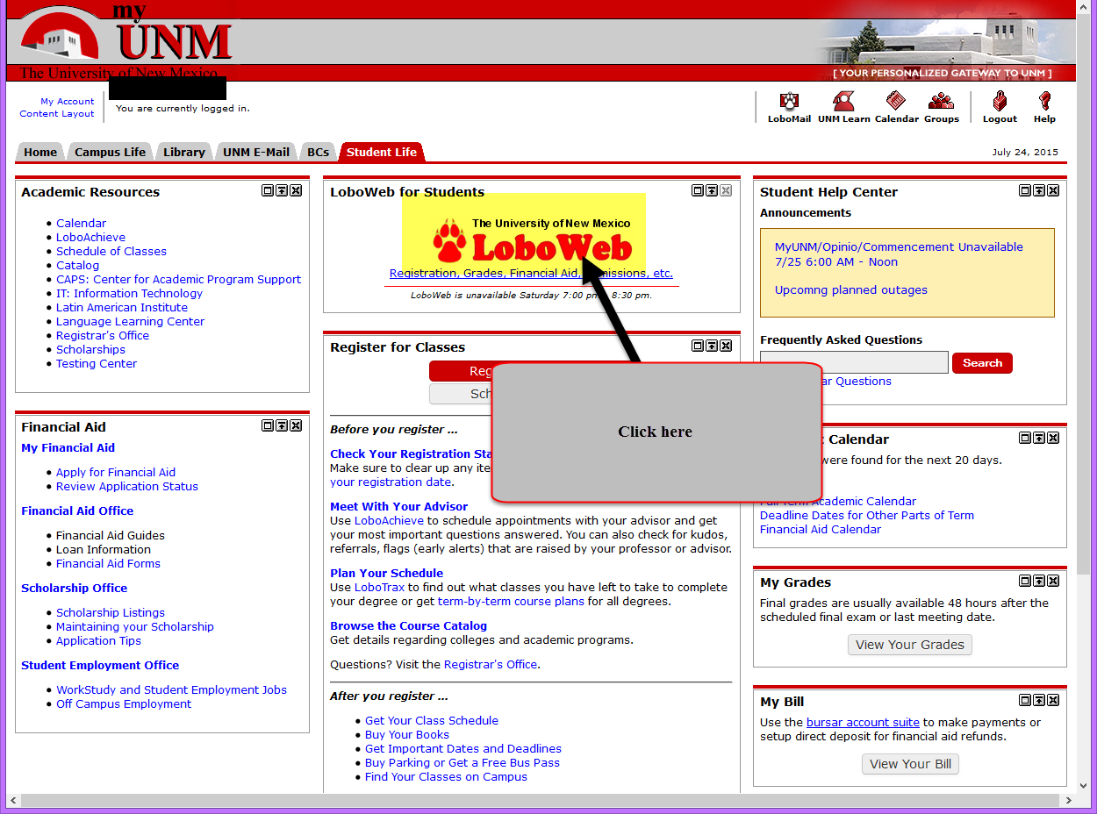
- Click on REGISTRATION & RECORDS link.
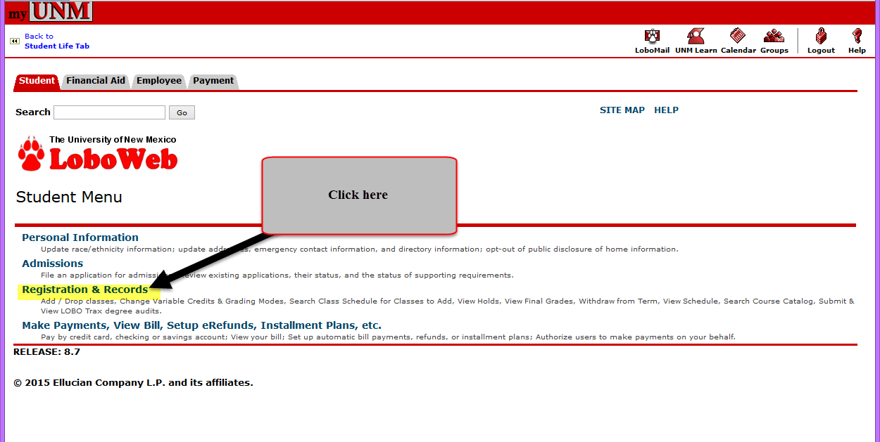
- Under the “RECORDS” section click on the “Submit or View LOBO Trax degree audits” link.
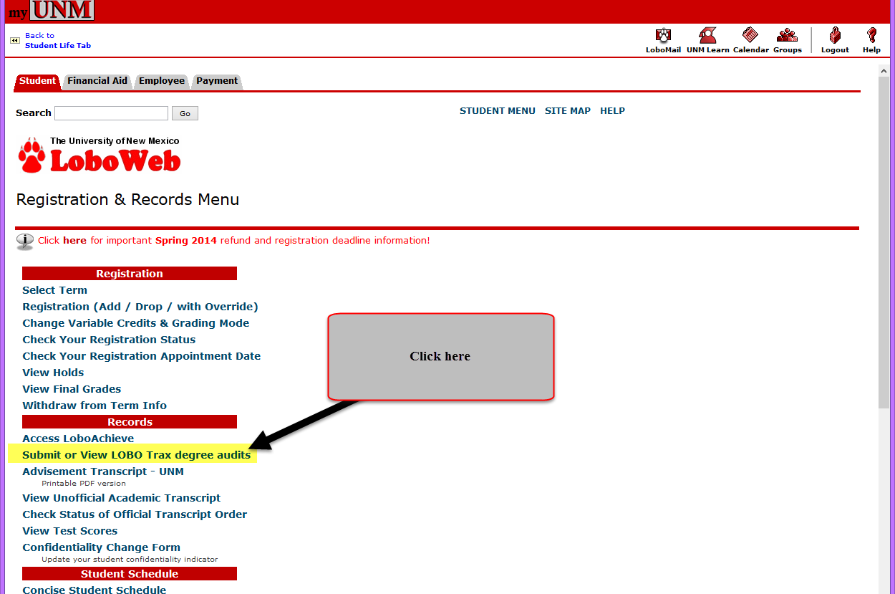
- Click on the “Submit an Audit” link to run your LoboTrax audit.
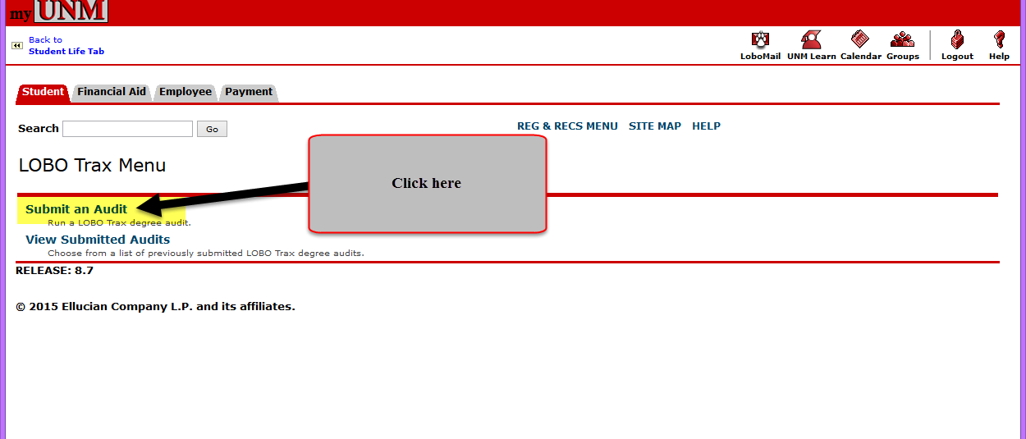
- You will need to sign in a second time so reenter your UNM Net ID and Password.
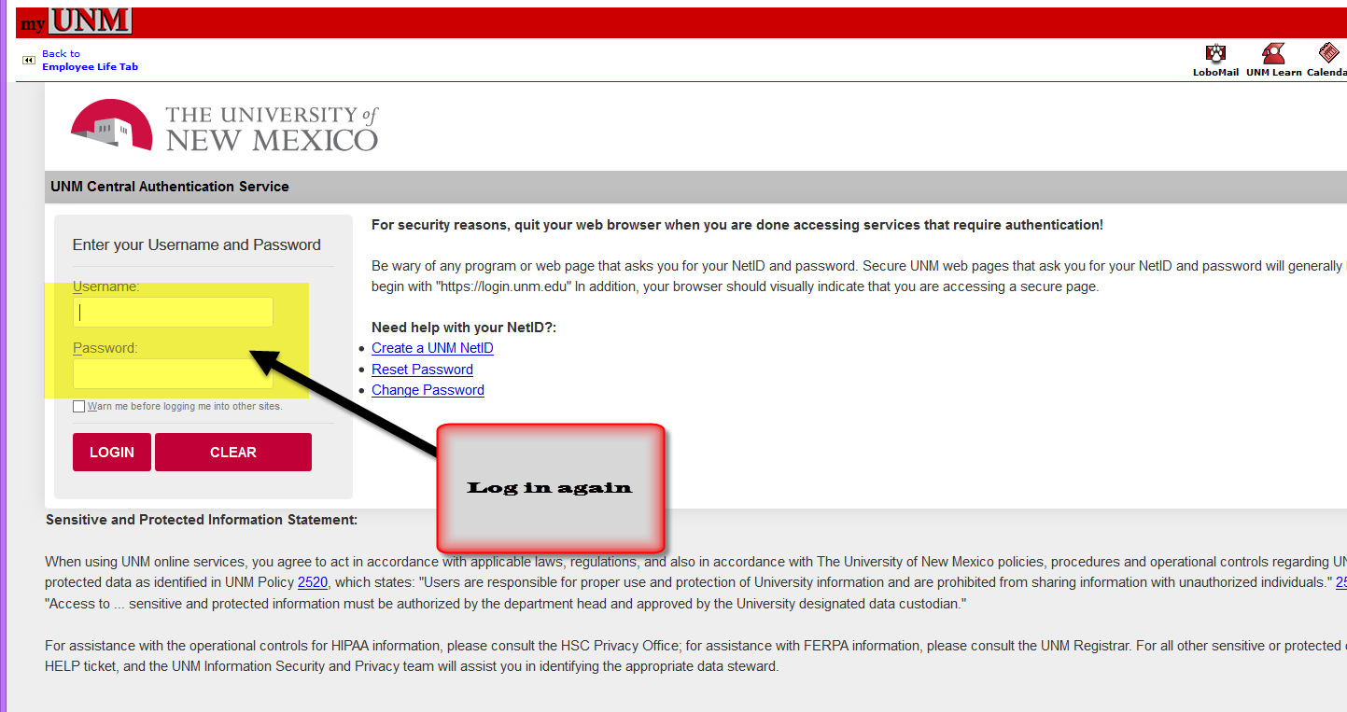
- Now you are in the new U.Achieve “LoboWeb” dashboard.
- It is here you can run two different kinds of audits: the “Current Program” audit or the “Run Selected Program” audit.
- If you want to run an audit for your CURRENT DEGREE, see below:
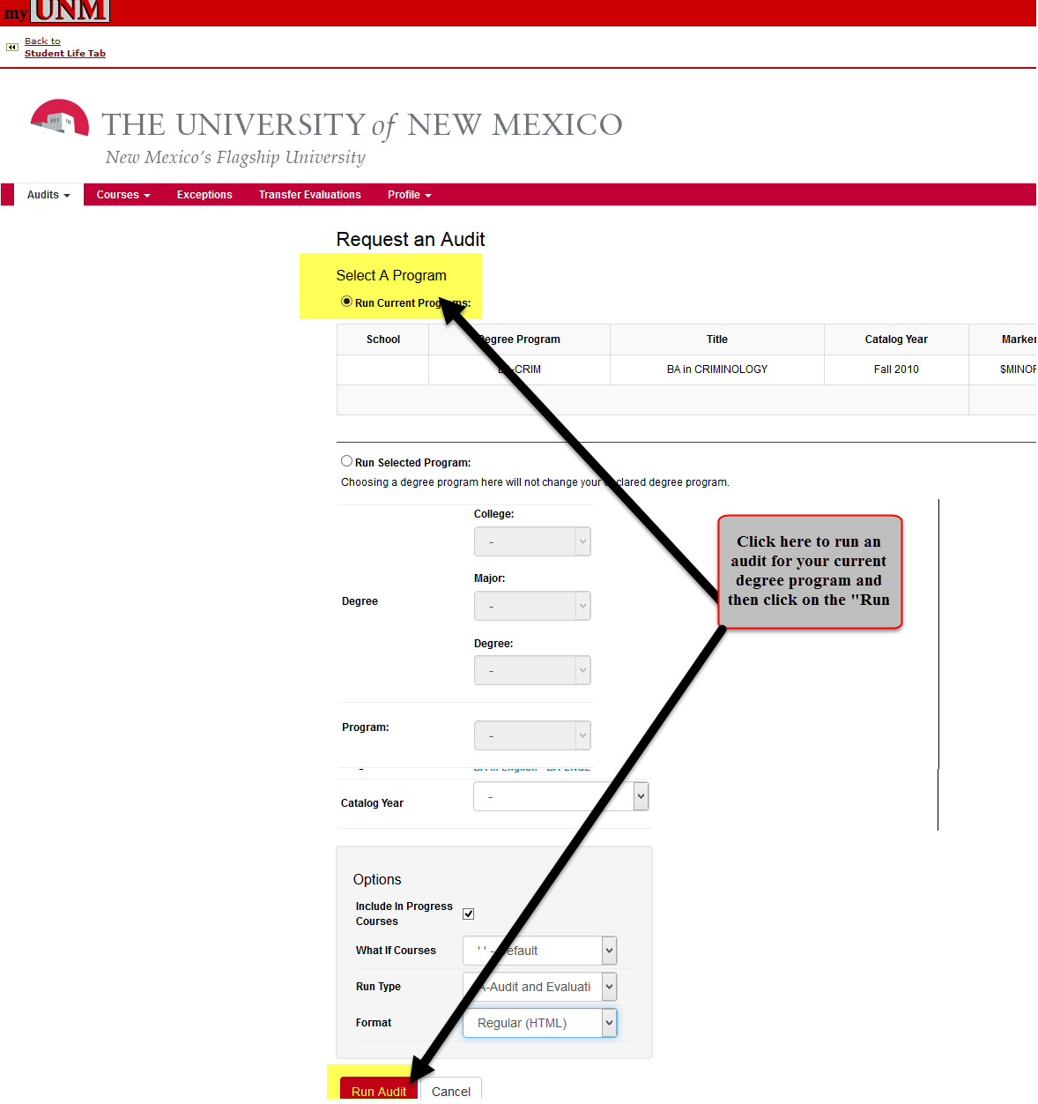
- As your audit is running you will see the following message:
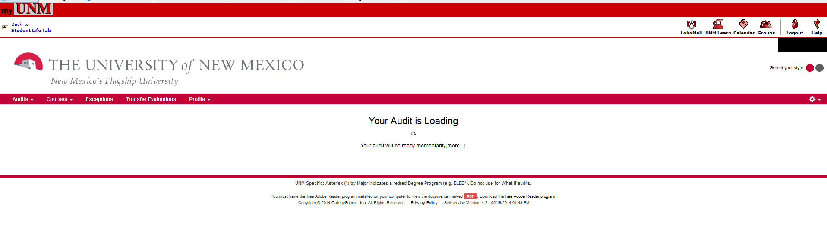
- When the audit is done running you will see a list of audits run within the last day or so. To open the audit you just ran, find it in the list and then click on the “View Audit” link to open it.
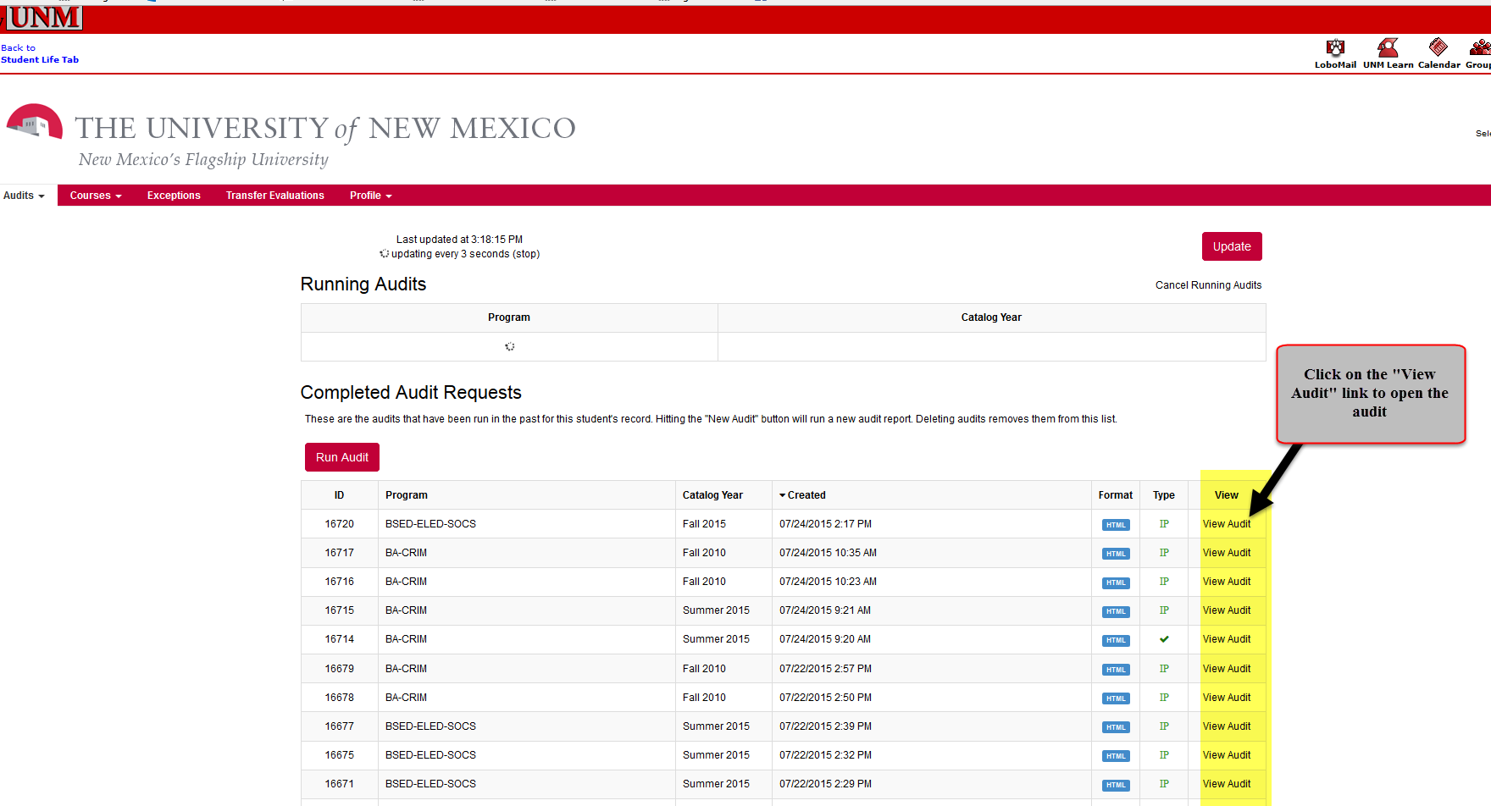
- Once the audit is done you will be able to view it, see below:
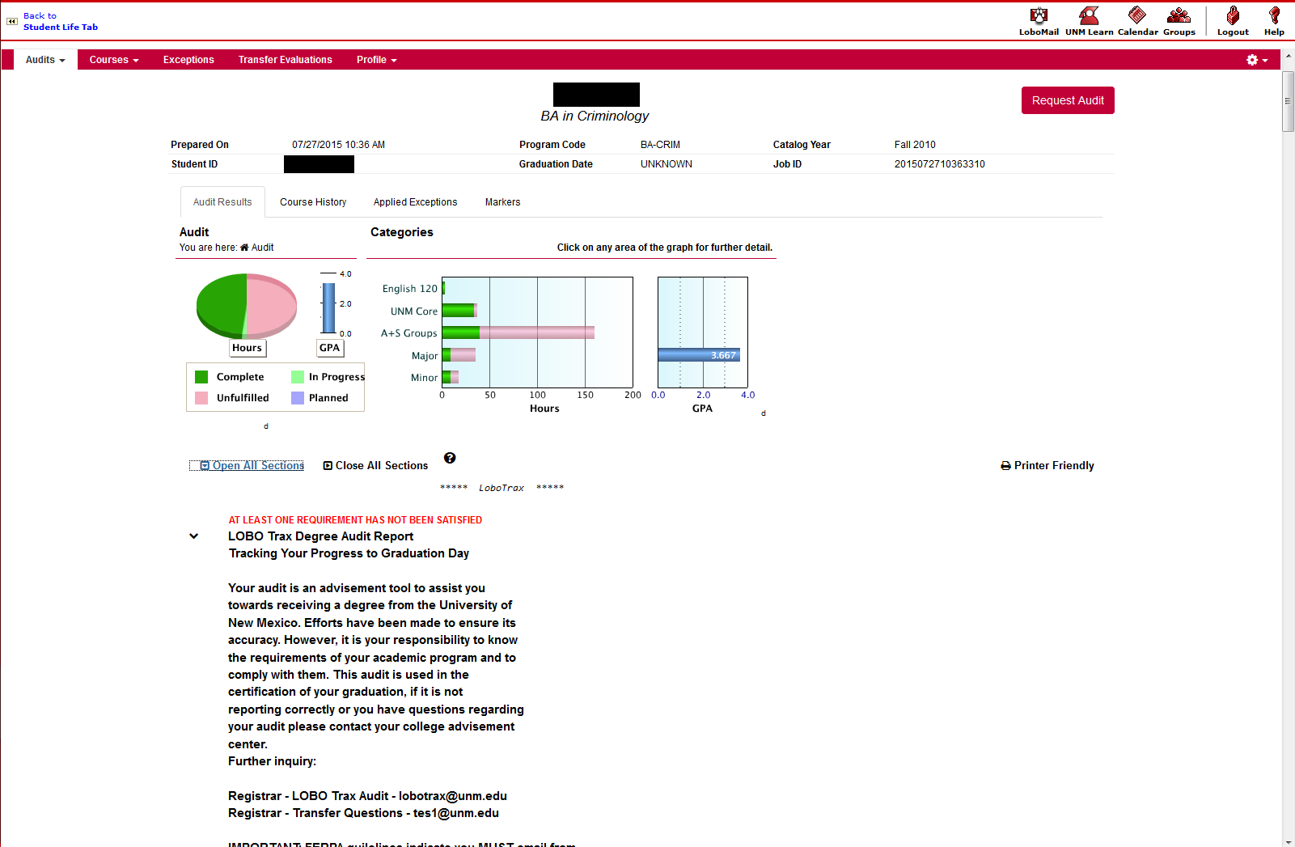
- If you want to run an audit for a DIFFERENT DEGREE PROGRAM from the one you are currently in select “Run Selected Program,” see below:
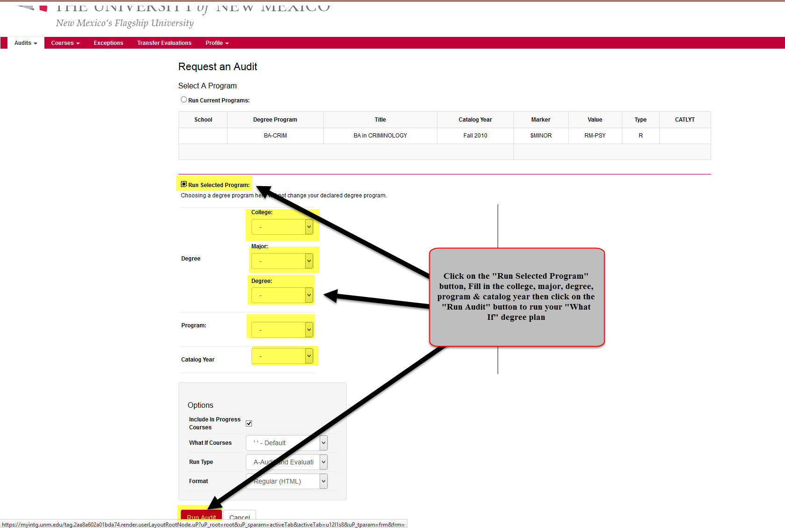
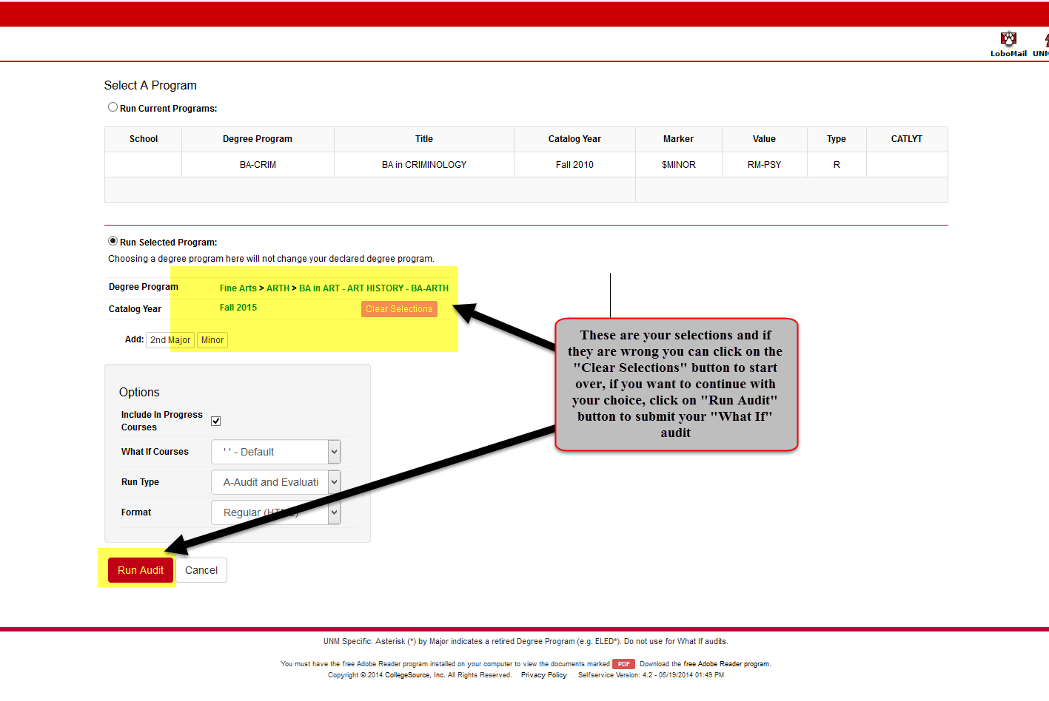
- As your audit is running you will see the following message:
- When the audit is done running you will see a list of audits run within the last day or so. To open the audit you just ran, find it in the list and then click on the “View Audit” link to open it.
- Once the audit is done you will be able to view it, see below:
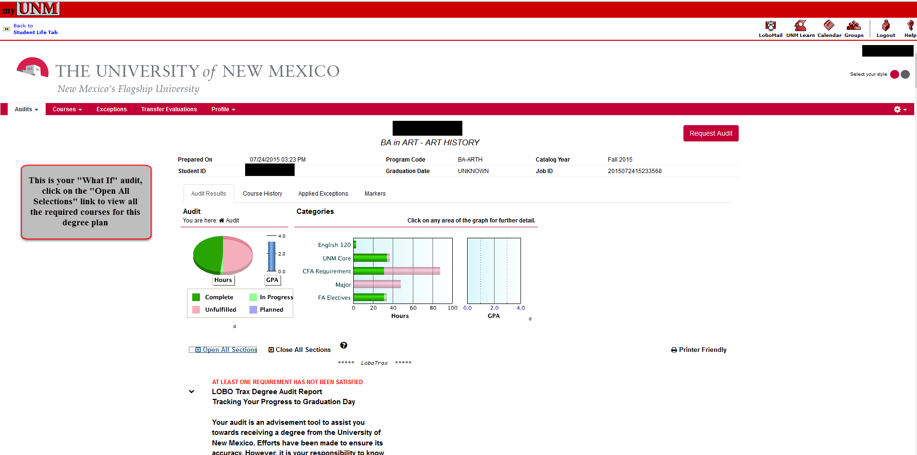
- There is a new Menu Bar at the top of your audit as well as new ways to view your UNM LoboTrax Audit, see below:
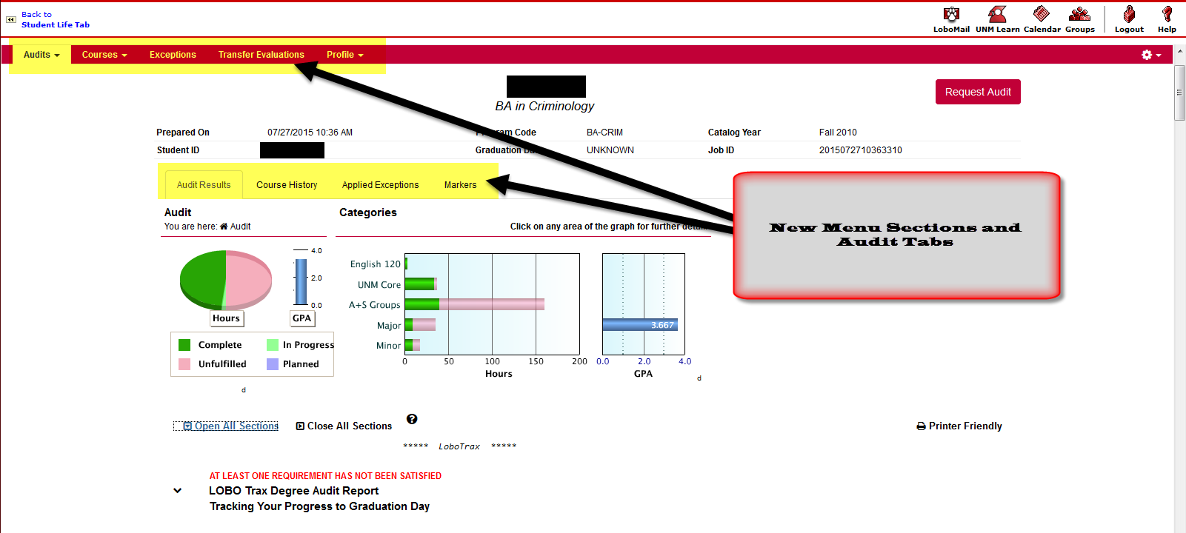
  - First Menu Section-AUDIT: Shows you the audit you just ran, see below:
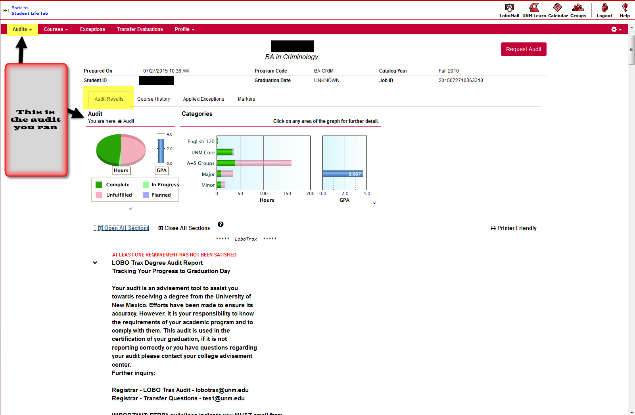
    - Under the “AUDITS” area right above the graphs and charts you can see four different tabs within your LoboTrax Audit:
      - AUDIT RESULTS TAB: click on your “Audit Results” to see the audit you just ran.
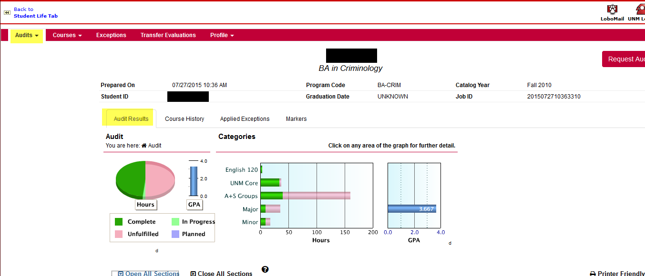
      - COURSE HISTORY TAB: You can see your completed courses, both UNM and transfer courses.
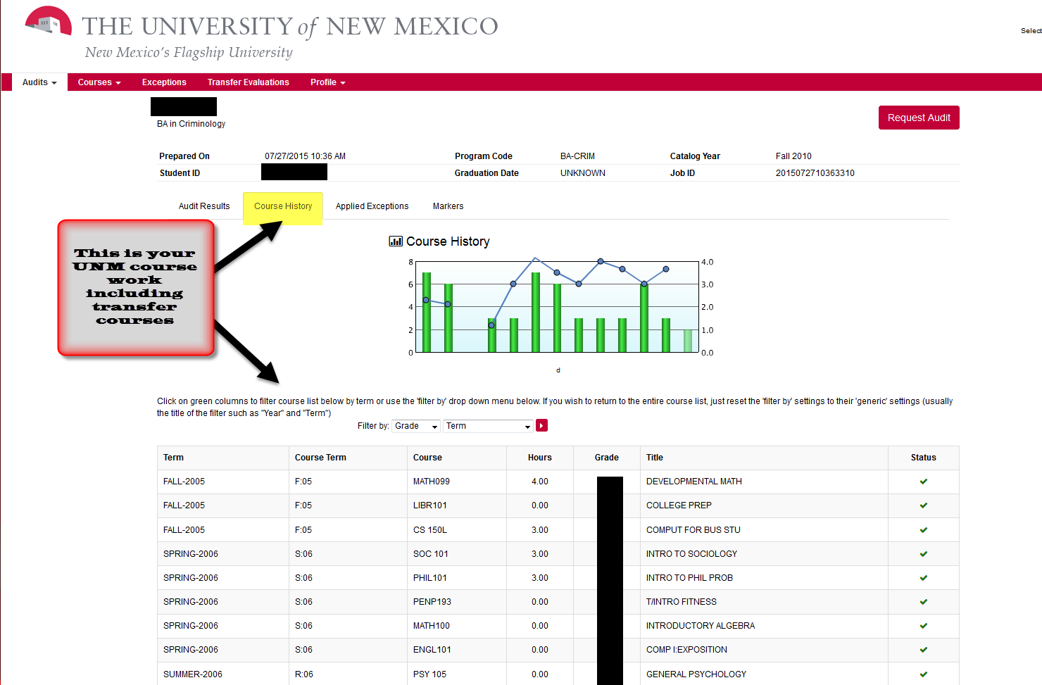
      - AUDIT EXCEPTIONS TAB: If any exceptions are applied to your UNM record you can view them under this tab. Questions about exceptions should be directed to your academic advisor.
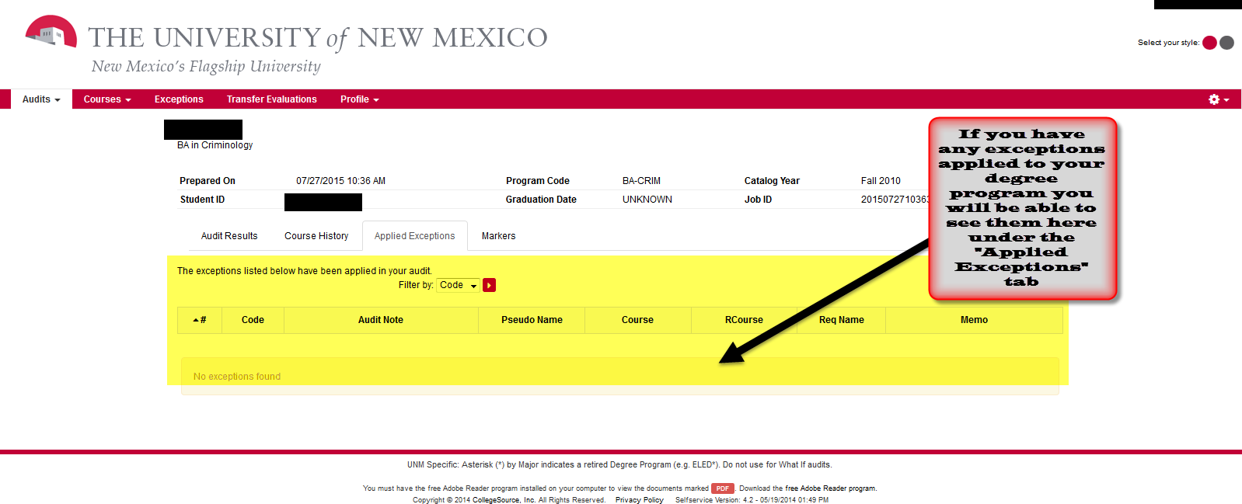
      - MARKERS TAB: If you have any markers for your UNM degree program you can view them under this tab.
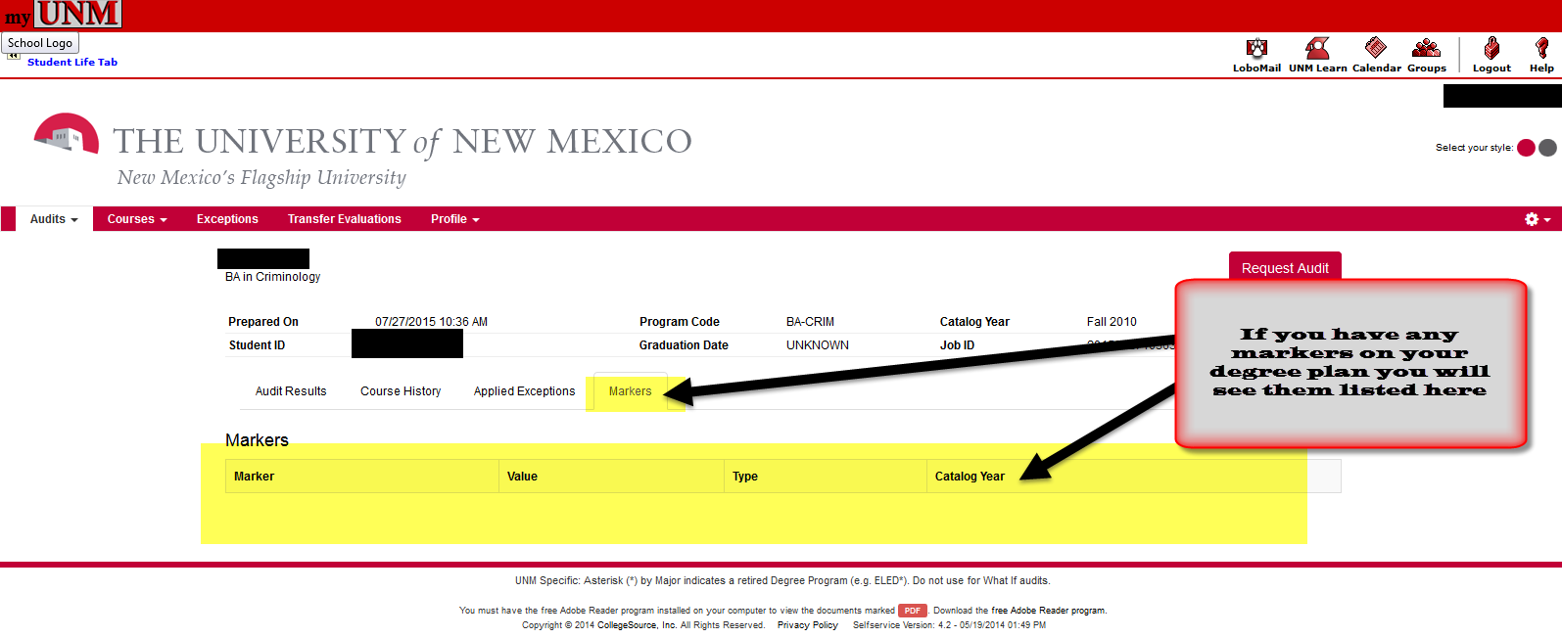
  - Second Menu Section-COURSES:
    - HOME: Displays all completed UNM and transfer courses. Questions about your UNM grades or missing courses should be directed to the Registrar’s Office via email at: unmreg@unm.edu. Questions about your degree program should be directed to your academic advisor.
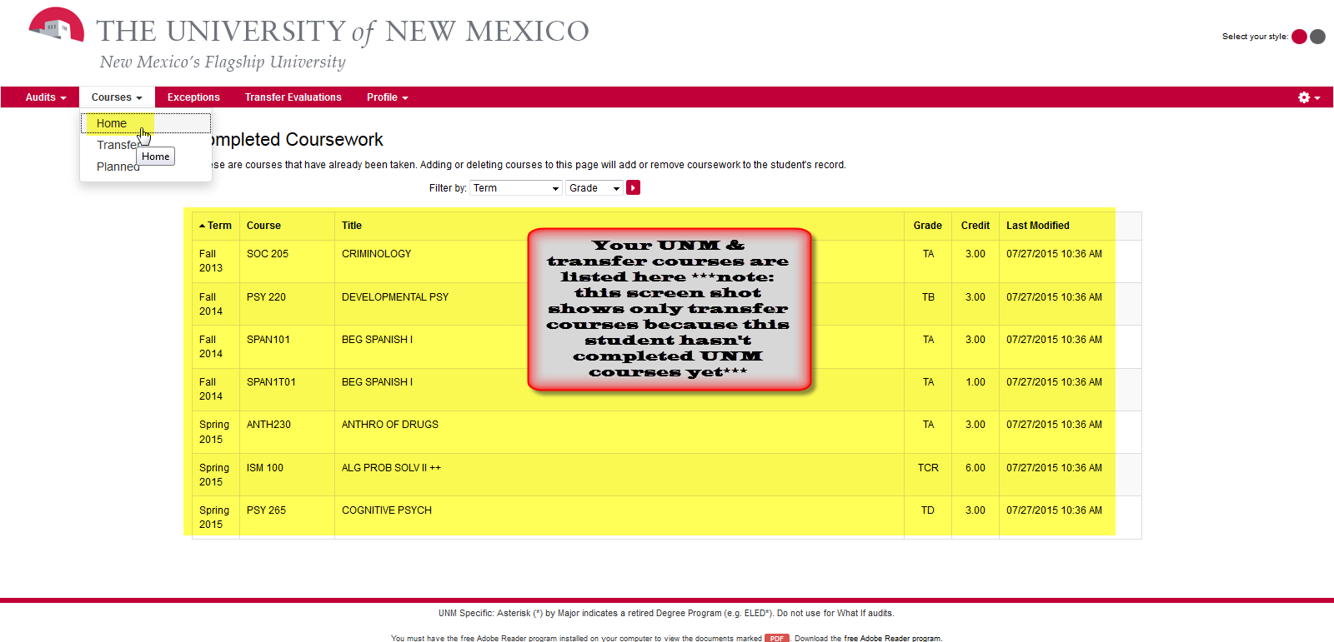
    - TRANSFER: Displays all completed transfer courses. For more information about your Transfer Evaluation see Student Info answer #3228. Questions regarding transfer course work should be directed to the Admission Office via email: apply@unm.edu.
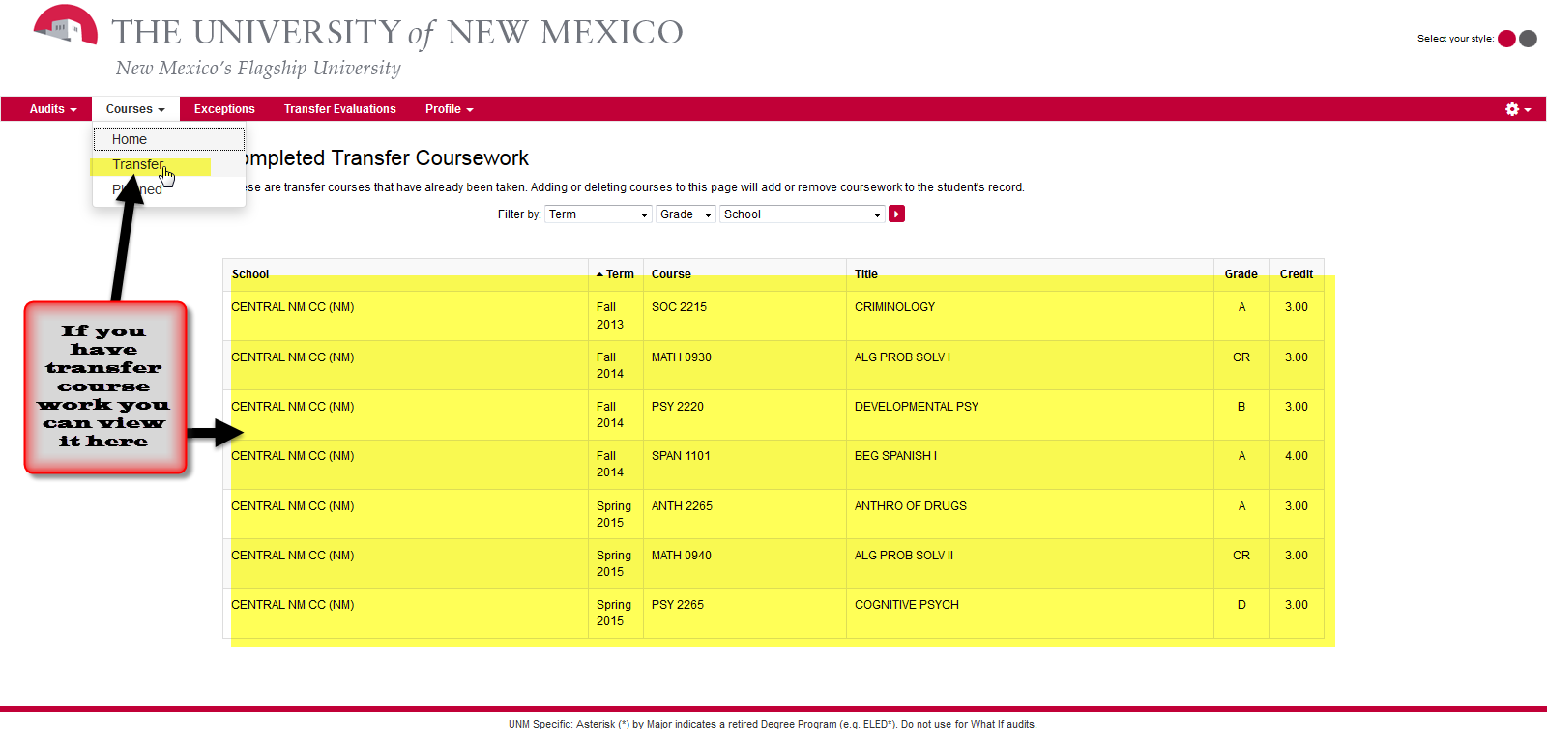
    - PLANNED: Displays any planned courses and allows user to add additional courses. *NOTE ABOUT PLANNED COURSES: Adding these to your audit does NOT register you for the courses.*
      - More detail about Planned Courses below:
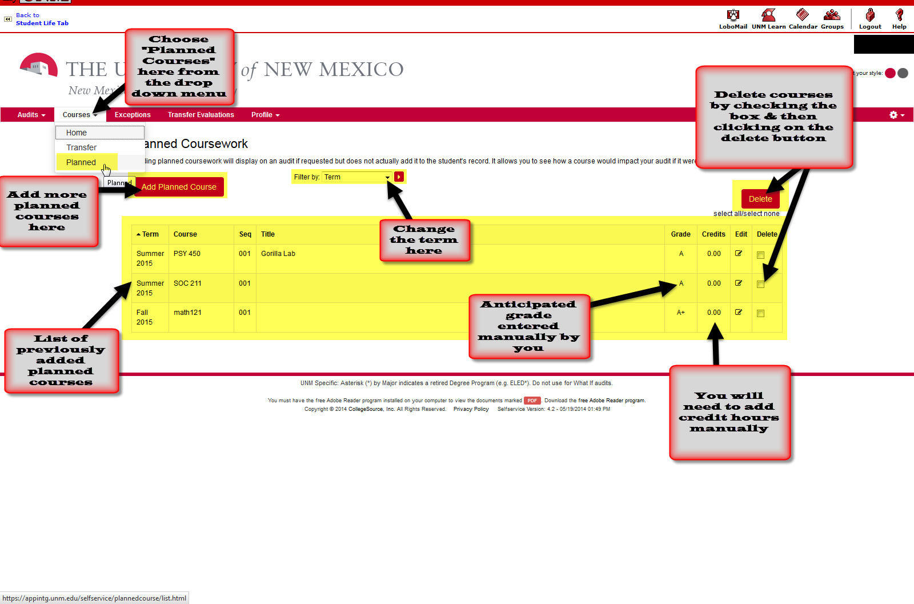
  - Third Menu Section-EXCEPTIONS: Offers another way to view any exceptions that may be applied to your degree program.
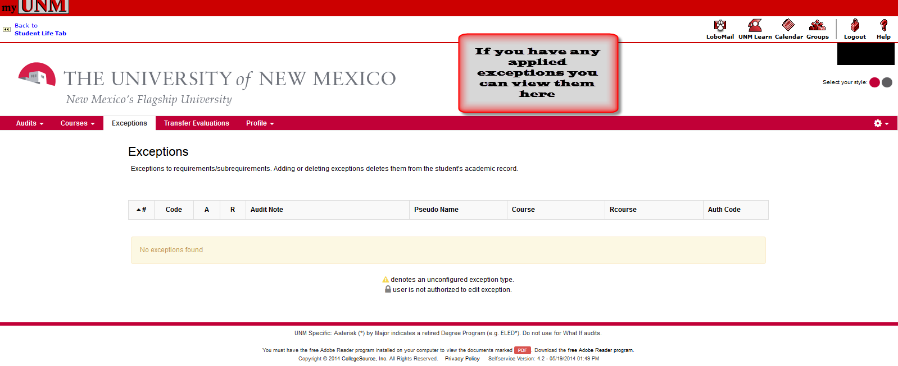
  - Fourth Menu Section-TRANSFER EVALUATIONS: Displays any transfer course work and indicates how the course was processed here at UNM.
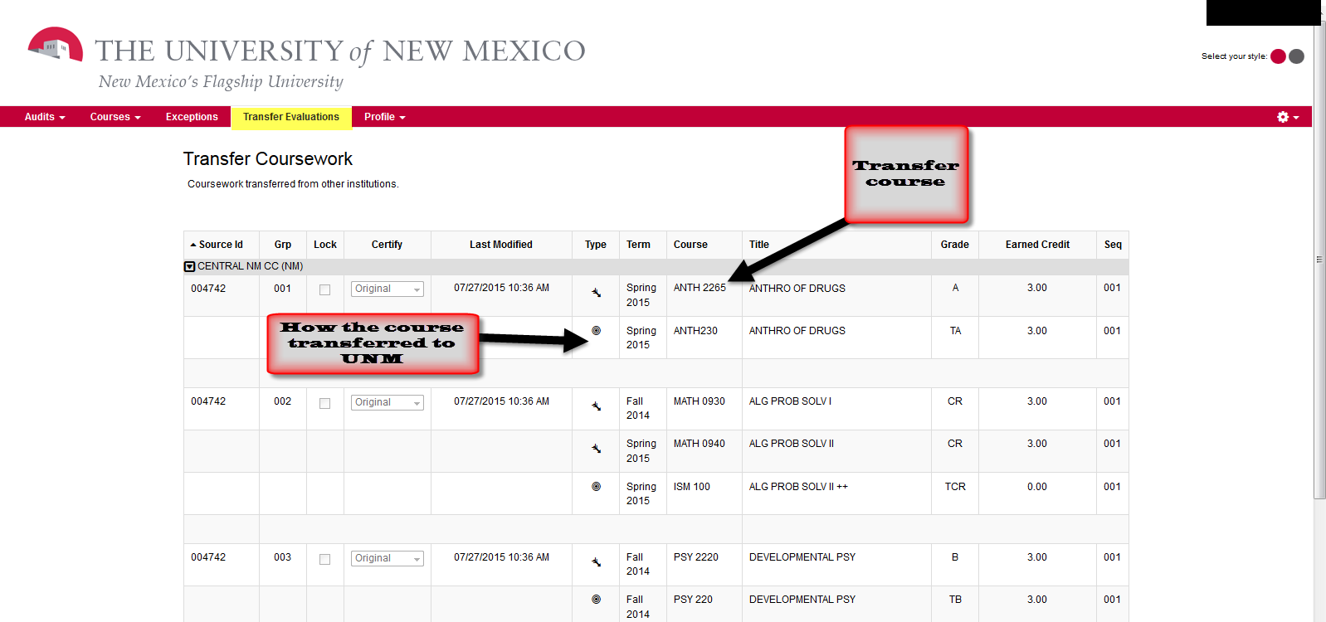
  - Fifth Menu Section-PROFILE: Displays your current degree program. ***IMPORTANT: Your academic advisor is the only person who can add, modify or delete your degree program at UNM. If your program appears incorrect or you have questions regarding your degree please contact your advisor directly. ***
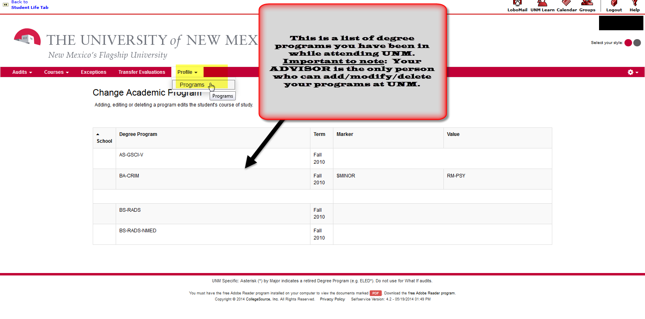
- Important information regarding audits:
  - Audits are only retained for a couple of days.
  - It is best to run a new audit each time to be sure you are viewing current data.
  - Questions regarding your degree should be directed to your academic advisor.
  - Questions regarding degree audit should be sent to the LoboTrax Degree Audit Team via email to: lobotrax@unm.edu.
  - Questions regarding processing of transfer transcripts should be sent to the Admission Office via email to: apply@unm.edu.
  - Questions regarding transfer articulation should be sent to the LoboTrax Transfer Team via email to: tes1@unm.edu.
- Student Info Answers:
    - #5124: What is a LoboTrax report?
    - #3052: How do I view a LoboTrax report?
    - #4193: How do I read and understand my LoboTrax audit?
    - #3228: How can I view my Transfer Course Evaluation?
*END*

